RE – Knowledge Organiser – Year 6
What is it like to be a Muslim living in Britain today?

KNOWLEDGE
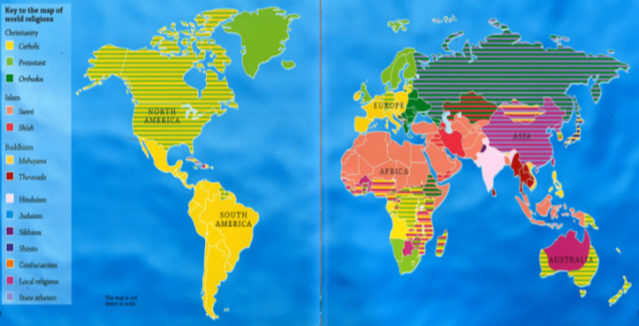
Did you know?
- Islam is the second most popular
world religion after Christianity.
- Most of the world’s Muslims live
in either Asia or Africa.

KNOWLEDGE
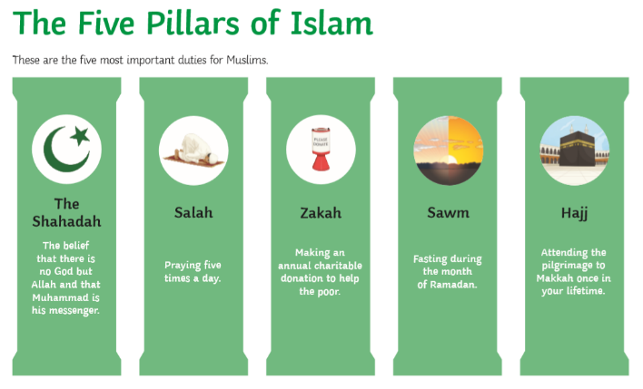
Did you know?
- The Five Pillars of Islam are the core
beliefs and practices that Muslims
follow.

Shahadah – There is no other God than Allah.
Salah – Praying five times a day.
Zakah – Giving to charity to help the poor.
Sawm – Fasting during the month of Ramadan
Hajj – Visiting Makkah once in your lifetime.

VOCABULARY | POINTS TO DISCUSS AT HOME
Sunni Shi’a  Sufi  Mosque – where Muslims worship Muslim – someone who follows the religion of Islam  worship  Qur’an – Islamic holy book  Hijab – a head covering worn by some Muslim women  Religion  Burkha – a long, loose garment covering the whole body worn by some Muslim women  Tolerance | - Where in Britain do most Muslims live and why?  - Why do so few Muslims live in North Devon?  - What is it like to be a Muslim living in Britain?  - What are the possible positives for a Muslim living in Britain?  - What are the possible negatives for a Muslim living in Britain?

