Sculpture

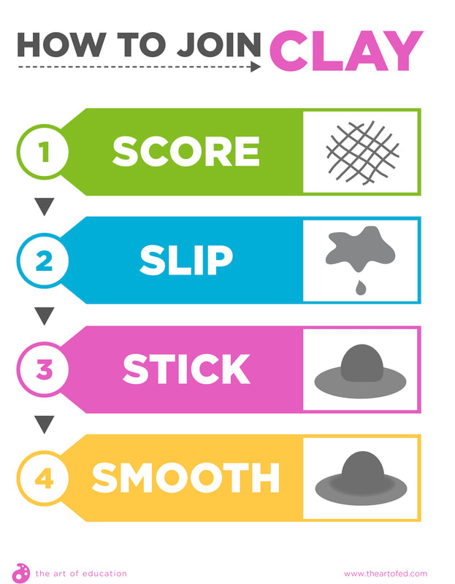
Vocabulary
• Slabs • Sculpt • Form
• Model • Representation • Manipulate
• Construct • Consistent • inconsistent
• Coils • Flamboyant • Freestanding
• Mould • Smooth • Vibrant
• Score • Slip • Stick
Alberto Giacometti - Swiss ARTIST AND SCULPTOR
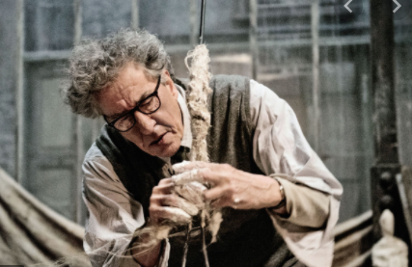
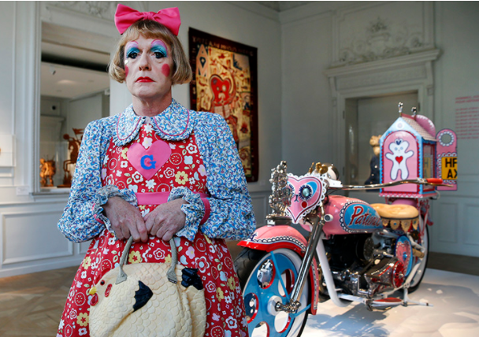
Grayson Perry - English ARTIST AND SCULPTOR
Materials
• Wire cutters • Wire mesh • Modrok
• Plaster • Strips • Clay
• Cutters



