Barefoot Computing - EYFS
Long Term Overview
 | EYFS – CAS Barefoot Curriculum
Year Group |  | Autumn 1 | Autumn 2 | Spring 1 | Spring 2er 1 | Summer 1 | Summer 2
Computing  Themes |  | Busy Bodies - Early Years | Winter Warmers - Early Years | Springtime - Early Years | Super Space - Early Years | Summer Fun - Early Years | Boats Ahoy - Early Years
Unit overview |  | Busy Bodies offers four activities that help children learn how their bodies move and grow. Using the provided resources, they explore body parts, growth, and movement, while also creating and adapting simple algorithms to build movement routines. | Winter Warmers offers three seasonal activities: making bird feeders, exploring patterns through snowman scarf designs, and discovering how igloos are built. | Three spring-themed activities introduce children to computational thinking through making junk scarecrows, exploring a rabbit run, and planting seeds. | Three space-themed activities help pupils develop computational thinking and problem-solving by creating rocket algorithms and spotting patterns in alien pictures. | Three activities encourage children to explore their surroundings, get creative by making a journey map, and discover seaside tangrams. | Boats Ahoy! takes children on a journey of discovery as they investigate different types of boats.

Despite computing not being explicitly mentioned within the Early Years Foundation Stage (EYFS) statutory framework, which focuses on the learning and development of children from birth to age five, at Dovedale we want to provide many opportunities for young children to develop their computational thinking and the necessary problem-solving skills needed for everyday life. Computational thinking is the foundation of our digital world, with the concepts forming the basis of much computer science. At Dovedale, we want our children to have rich experiences that will provide them with the foundations in computing to transition successfully into the ‘Teach Computing Curriculum’.

England’s national curriculum for computing states that:
"a high-quality computing education equips pupils to use computational thinking and creativity to understand and change the world."

Additionally, the problem solving of Computational Thinking closely aligns with the Characteristics of Effective Learning. Therefore, by aligning EYFS provision to Computational Thinking, we use the same vocabulary as used by our colleagues in KS1 and ensure progression throughout school.

At Dovedale, through Computing at School’s (CAS) Barefoot Computing resources, the children will be provided with both plugged and unplugged opportunities to develop their computational thinking. Computational thinking is about looking at a problem in a way in which a computer can help us to solve it. This is a two-step process:
- First, we think about the steps needed to solve a problem.
- Then, we use our technical skills to get the computer working on the problem.

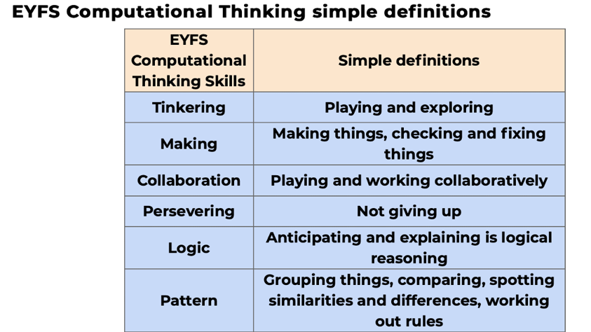
Computational thinking involves six different concepts (Logic, Algorithms, Decomposition, Patterns, Abstraction and Evaluation) and five computational thinking approaches (Tinkering, Creating, Debugging, Persevering and Collaborating).
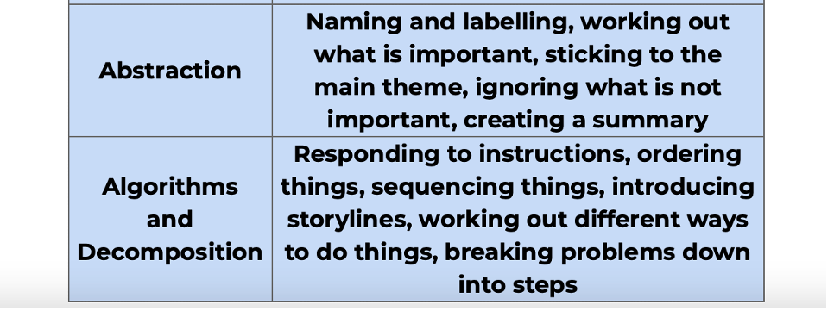

Digital Literacy Enhancement provided through continuous provision opportunities and cross curricular projects.

