
Dovedale Primary School Computing Curriculum
Long Term Overview
Year Group | Autumn 1 | Autumn 2 | Spring 1 |  | Spring 2er 1 |  |  | Summer 1 | Summer 2
Online Safety through ‘Project Evolve – Education through a Connected World’ –
Linked throughout Computing themes and ‘Wellbeing Wednesday Assemblies – See below for additional detail.
EYFS | Barefoot Curriculum – See below for additional detail.
Computing  Themes | Computing Systems and networks  ‘Computer User’ | Creating Media  ‘Media Creator’ |  | Programming A  ‘Programmer’ |  | Data and Information  ‘Data Handler’ | Creating Media  ‘Media Creator’ |  | Programming B  ‘Programmer’
Year 1 | Technology  around us | Digital painting |  | Moving a robot |  | Grouping data | Digital writing |  | .  Programming Animations
Year 2 | Information technology  around us | Digital photography |  | Robot algorithms |  | Pictograms | Making music |  | Programming Quizzes
Year 3 | Connecting computers | Stop-frame animation |  | Sequencing sounds |  | Branching databases | Desktop publishing |  | Events and actions in programs
Year 4 | The internet | Audio production |  | Repetition in shapes |  | Data logging | Photo editing |  | Repetition in games
Year 5 | Sharing information | Video production |  | Selection in physical computing |  | Flat-file databases | Vector drawing |  | Selection in quizzes
Year 6 | Internet communication | Webpage creation |  | Variables in games |  | Introduction to spreadsheets | 3D modelling |  | Sensing
Each year group will develop their digital literacy skills through an annual Word or PowerPoint project, using research, collaboration, oracy and presentation to create and share their work. Each class will have two rotating Tech Champions who support the responsible use, charging and storage of technology.
EYFS – CAS Barefoot Curriculum
Despite computing not being explicitly mentioned within the Early Years Foundation Stage (EYFS) statutory framework, which focuses on the learning and development of children from birth to age five, at Dovedale we want to provide many opportunities for young children to develop their computational thinking and the necessary problem-solving skills needed for everyday life. Computational thinking is the foundation of our digital world, with the concepts forming the basis of much computer science. At Dovedale, we want our children to have rich experiences that will provide them with the foundations in computing to transition successfully into the ‘Teach Computing Curriculum’.

England’s national curriculum for computing states that:
"a high-quality computing education equips pupils to use computational thinking and creativity to understand and change the world."

Additionally, the problem solving of Computational Thinking closely aligns with the Characteristics of Effective Learning. Therefore, by aligning EYFS provision to Computational Thinking, we use the same vocabulary as used by our colleagues in KS1 and ensure progression throughout school.

At Dovedale, through Computing at School’s (CAS) Barefoot Computing resources, the children will be provided with both plugged and unplugged opportunities to develop their computational thinking. Computational thinking is about looking at a problem in a way in which a computer can help us to solve it. This is a two-step process:
- First, we think about the steps needed to solve a problem.
- Then, we use our technical skills to get the computer working on the problem.

Computational thinking involves six different concepts (Logic, Algorithms, Decomposition, Patterns, Abstraction and Evaluation) and five computational thinking approaches (Tinkering, Creating, Debugging, Persevering and Collaborating).
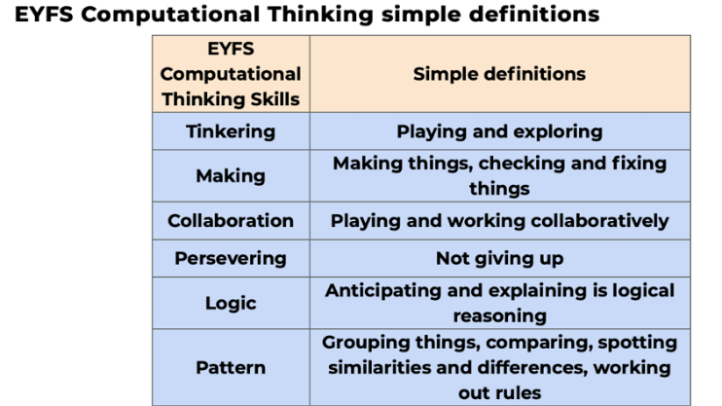
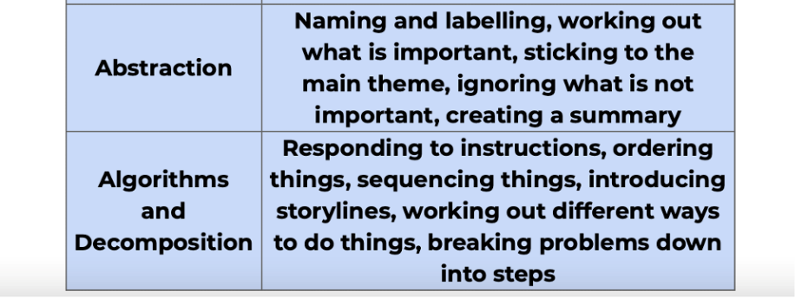

Not only will EYFS engage with Barefoot Computing resources but Digital Literacy enhancement provided through continuous provision opportunities and cross curricular projects.

Online Safety - Project Evolve - Education through a connected world
At Dovedale Primary School, a central focus of implementing our Computing curriculum is to ensure our children are safe and have the necessary skills, knowledge, understanding and attitudes to keep themselves and others safe online. We want our children to enjoy being online, whilst accessing safe online spaces and benefit from all the opportunities that a connected world can bring them, which is appropriate to their age and stage of learning.

At Dovedale, we have implemented ‘Project Evolve – Education for a Connected World’, a framework which aims to support and broaden the provision of online safety education, so that it is empowering, meaningful, builds resilience and effects positive culture change. The objectives promote the development of safe and appropriate long-term behaviours, and support educators in shaping the culture within their setting and beyond.

Online safety is threaded through our Computing Themes across the academic year for each year group. Where relevant to the lesson, online safety objectives will be covered through a direct link to ‘Project Evolve – Education for a Connected World’. Additionally, at Dovedale we have implemented these eight strands into our ‘Wellbeing Wednesday Assembly’ sessions which will take place each week. Some strands are incorporated into PSHCE lessons due to the objective content and suitability. Therefore, we are implementing full coverage over each area. Each strand will cover the appropriate knowledge, skills, behaviours, and attitudes relevant and suitable for each year group and this will continue to progress over each year. Therefore, there are many opportunities for our children to reflect upon online safety already taught, through ‘Flashback Fluency’ and to develop a deeper understanding of online safety.

These are the 8 strands in ‘Project Evolve – Education for a Connected World’:


