Autumn Term 1. Year 6.  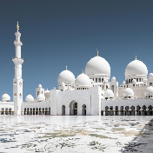 | 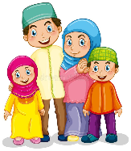  What is it like for a Muslim living in Britain today?  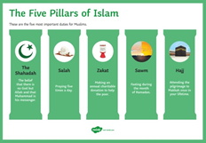 | 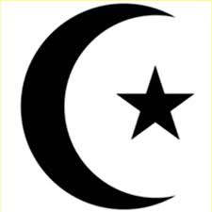  Religious focus: Islam.
Key Vocabulary: | 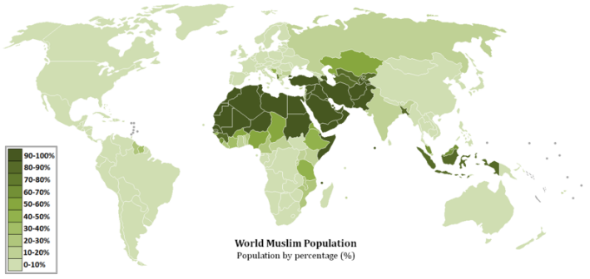  - Did you know Islam is the 2nd most popular world religion after Christianity?  - Most of the world’s Muslims live in Asia or Africa.  - On the world map, the darker colours indicate a larger Muslim population.
Religion – A way of faith and worship.
Muslim – someone who follows the Islamic religion.
Mosque – where Muslims worship
Qur’an – Islamic holy book
Hijab – a head covering worn by some Muslim women. | 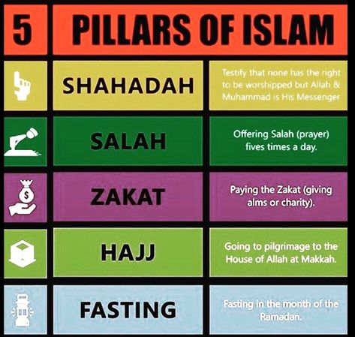  The Five Pillars of Islam are the core beliefs and practices that Muslims follow.  - Shahadah – There is no other God than Allah.  - Salah – Praying five times a day.  - Zakah – Giving to charity to help the poor.  - Sawm – Fasting during the month of Ramadan.  - Hajj - Visiting Makkah (Mecca) once in your lifetime.
Burkha – a long, loose garment covering the whole body worn by some Muslim women.
Immigrate - for an individual or a family to enter a new country from their country of origin.
Emigrate – for an individual or family to leave their own country in order to settle permanently in another.
Migrate – For a large number of people or animals to move from one country or region to another. (Not just one person or one family).
Ramadan.  The 9th month of the Islamic calendar is the holiest month for Muslims. They ‘fast’, pray, reflect and come together as a community. | Qur’an (Koran).  The holy book of Islam.  Considered by Muslims to be the word of Allah (God). It is written and read in Arabic. | Shahadah.  The 1st of the Five Pillars of Islam. It is the most sacred statement in Islam - there is no other God than Allah.

