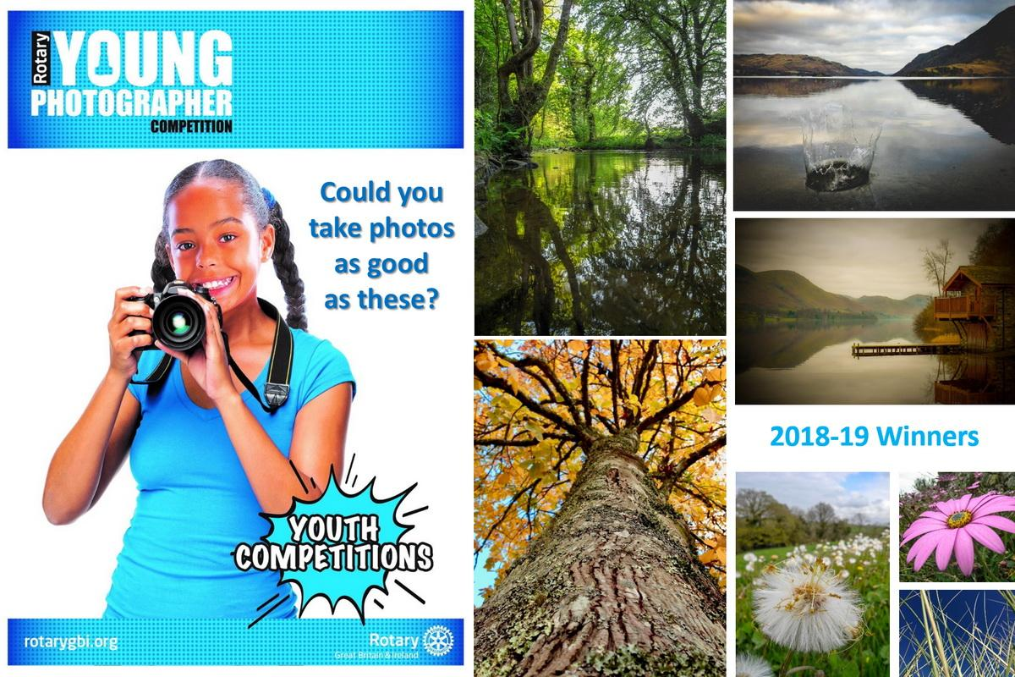
2020-2021
Information Pack
The Rotary Club
of Long Eaton

1.
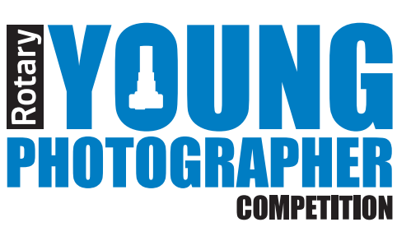

Information Pack for 2020 – 2021
Theme – ‘Wild Nature’
Introduction
The Young Photographer Competition is a well-established and successful competition organised and promoted by Rotary International in Great Britain and Ireland (Rotary GB&I)
There are three stages to the competition, each designed to support and encourage the development of photographic skills. Some stages may have more than one round.

Aims & Objectives
The Competition aims to encourage young people to:
• Experiment with photography
• Use digital and/or traditional methods of photography
• Express their ideas through the medium of photography
• Demonstrate Interpretation of the topic

Who Can Take Part?
The Competition is open to all schools and college communities and those who are home educated, along with any other young people’s community organisations, for example, community RotaKids, community Interact, Scout Groups and Girl Guides.
There are three age groups:
Junior: 7 to 10 years old
Intermediate: 11 to 13 years old
Senior: 14 to 17 years old

Entrants must not be over the upper age parameter for each age group on 31st August 2020.
With the age qualifying date of 31st August 2020, it should be noted that some junior entrants may be 11, intermediate entrants may be 14 and some senior entrants may be 18 at the time of some or all the stage competitions i.e. a competitor who may be 17 on 31st August but turns 18 on 1st September is allowed to enter. Competitors must include their age on the application form.
Students should enter the competition organised by The Rotary Club of Long Eaton through their respective group, as detailed above.
Competitors, schools, colleges and organisations may participate in a competition held in a Rotary club/district outside of their geographical boundary but may compete in only one club/district event.
2.
The Three Stages of the Competition

Local Heats
These are organised by local Rotary clubs between January and April 7th 2021. The winners of each age group are entered into a district competition.

District Competitions
These are organised by Rotary by 21st April 2021. The Winners of each age group are entered into the national final.

National Final
This is organised by Rotary. One entry per age group from each district may be submitted by 21st May 2021 to the Rotary Support Centre.

The dates for local heats and district competitions will be determined locally. Entrants should check dates with their local Rotary club in the first instance.

Competition Guidelines:

• To produce one (1) photo max size 10GB
• Each entrant must provide a word document saved as a PDF aiming for 50 words or more outlining and commenting on the reason for the image and its relevance to the theme.

Important Notice: Please note that photographs and videos of people under 18 years old must be accompanies by written permission from the parent, guardian or carer of the person(s) photographed. Please attach Individual Rotary GB&I ‘From B: Consent form for the use of photographs, film or video recordings of children or vulnerable adults’

Entries should be sent to the stage organiser by the closing date.

Winners’ photographs will be displayed at the Volunteer Expo

Judges
Persons with appropriate skills, appointed by Rotary, will apply the judging criteria below.

Judging Criteria
Judges will consider technical merit, content and composition, imagination and style.

Only in exceptional circumstances and at the sole discretion of the competition organiser, will correspondence or discussions be entered into following the competition.

Prizes
At all stages of the competition, competitors will receive a certificate of participation. The national winners will be given an opportunity to participate in a vocational experience with a professional photographer.
3.

How to Enter
To enter a local heat, complete the entry form attached and submit it along with their photograph and the PDF word document describing why this picture was submitted and its relevance to the theme ‘Wild Nature’. Please send your items together in a jpeg file with your first name and surname and age to: youngphotographerRCLE@outlook.com . Please put your full name and age in the subject line so that we can identify your work.

Rotary Youth Competitions
This Young Photographer competition is one of eleven competitions for young people organised by Rotary International in Britain and Ireland. The others are: Young Artist, Young Chef, Youth Debate, Young Environmental Project, Young Filmmaker, Young Musician, Young Writer, Young Citizens Awards and the Technology Tournaments. To find out more about these competitions and other opportunities please contact your local Rotary club in the first instance.

Working with Children
Rotary International in Great Britain and Ireland has adopted this statement of policy in working with children, vulnerable adults and those with disability.
The Needs and rights of the child, the elderly, the vulnerable and those with disability take priority. It is the duty of every Rotarian to safeguard to the best of their ability, the welfare of and prevent the physical, sexual or emotional abuse and neglect of all children, the elderly, persons with disability or otherwise vulnerable persons with whom they come into contact during their Rotarian duties.

Contact Details
If you would like any further information please contact us using the details below
Rotarian Mrs Barbara James
26 Holly Avenue
Breaston
Derbyshire
Phone: 01332 874 299
Mobile: 07734983626
Email: barbaralesleyjames@gmail.com

The Rotary Club
of Long Eaton

4.

Young Photographer Competition
The Rotary Club of Long Eaton
First Name: | Surname:
DOB: | Home Address:
Email Address: | Home Telephone Number:  Mobile Telephone Number:

I agree to my child participating in the Long Eaton Rotary Club Young Photographers competition, their entry photos may be published in local newspapers or Rotary Publications.
Signature Parent/ Guardian: _____________________________________________
Print Name: __________________________________________________________
Date: ______________________________
Organisation participating in competition ie school, Scout Group, Girl Guides etc.
____________________________________________________________________________
DATA PROTECTION
In signing this document, you agree to the Rotary Club of Long Eaton, keeping the above details on securely on record for contact purposes only. These details will not be passed onto any other group or person.
Rotary Interact contacts:
Rotarian Mrs Barbara James
26 Holly Avenue, Breaston
Derbyshire
DE72 3BG
Phone: 01332 874299 or 07734983626
Email: barbaralesleyjames@gmail.com

5.

