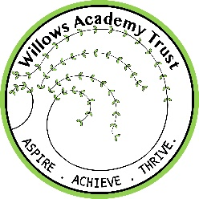
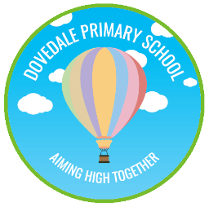
DOVEDALE PRIMARY SCHOOL
Willows Academy Trust

Dovedale Avenue, Long Eaton,
Nottingham. NG10 3HU
Telephone 0115 973 5984
Headteacher: Sarah Houseman
E- Mail: headteacher@dovedale.derbyshire.sch.uk
Web site – www.dovedaleprimaryschool.co.uk

Aiming High Together

14th February 2022

Hello Everyone,

We are celebrating the British Science week from the 14th to the 18th of March this year in school. This year the theme is “Growth”. Throughout the week we will be having lots of fun and exciting activities.

On Tuesday the 15th of March, we will be dressing up. Children can come in dressed as they like, around the theme of growth or as scientists.

This year we have decided to bring an outside provider called the Explorer Dome to do a science workshop in school. This will be held on Wednesday, the 16th of March (for EYFS and KS1) and Friday, the 18th of March (for KS2).
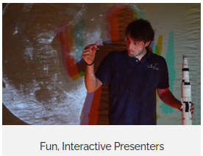






On Thursday, the 17th of March, there will be a science investigation carousel, which will include lots of fun experiments and investigations that the children can get involved in.

To cover the costs we are requesting a £3 donation for the science workshop and the science carousel.

Payment for this is through our online school money system.
- You will need to access eduspot.co.uk and sign in via the schoolmoney parent login
- You will be asked for your mobile number, email address and password
- Then you will be asked to enter your child’s first name.
- Click on Science Week 2022
- Proceed to payment

There will also be a poster competition organised by the British Science Association. Details are given in a separate letter. Entries are due in by the 1st of April 2022.

We will really appreciate your support for the science week and look forward to make it a fun and exciting week for our children.

Thank you!

Kind regards,

Mrs Ganguly.
(Science lead)

