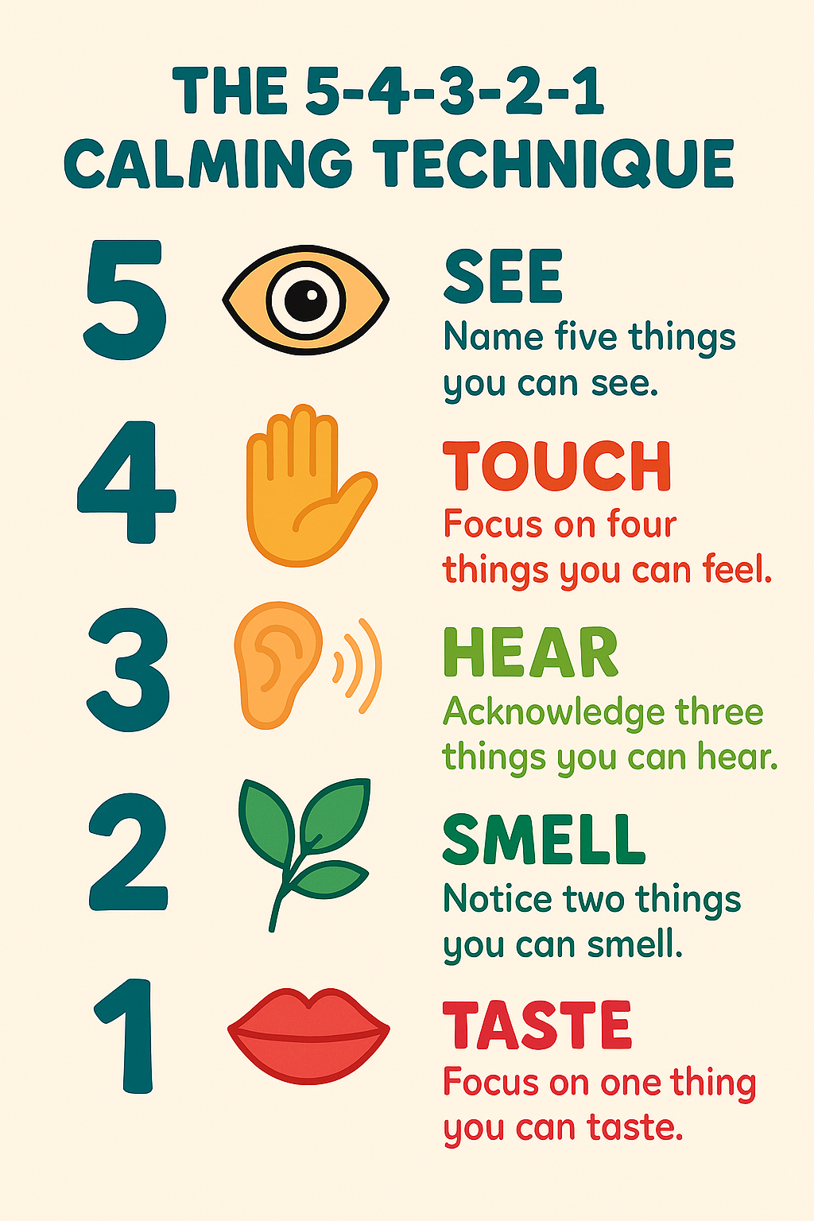
🌈 5-4-3-2-1 Calming Technique for Kids
This is a fun and easy way to help your brain feel calm and your body feel safe. You can do it anywhere—at school, at home, or even in the car!
🖐️ 5 – Look Around
Name 5 things you can see.
👀 Tip: Pretend you're a detective! What’s something you’ve never noticed before?
“I see a red book, a sparkly pencil, a cloud outside, my friend’s shoes, and a poster on the wall.”
✋ 4 – Feel
Touch 4 things around you.
🧸 Tip: Try to find things that feel different—soft, rough, warm, cold.
“I feel my jumper, the smooth table, my hair, and the cool water bottle.”
👂 3 – Listen
Name 3 things you can hear.
🎧 Tip: Close your eyes like a superhero using super-hearing!
“I hear birds, someone talking, and the ticking clock.”
👃 2 – Smell
Notice 2 things you can smell.
🌸 Tip: If you can’t smell anything right now, think of your favourite smells!
“I smell my hand soap and my lunchbox.”
(Or: “I imagine cookies and fresh grass.”)
👅 1 – Taste
Say 1 thing you can taste.
🍓 Tip: If you’re not eating, just notice what your mouth feels like.
“I taste my toothpaste.”
(Or: “I imagine strawberries.”)
💡 Extra Tips for Kids
You can whisper each step to yourself or say it in your head. Try drawing or colouring each step if you like being creative.
Use it like a “magic spell” to help your brain feel better when you’re upset or worried. Grown-ups can do it with you too!

