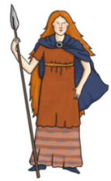
Boudicca
BC | Before Christ
AD | Anno Domini
Artefact | An item made by humans- preserved, discovered by archeologist.
Aqueduct | A pipe or channel designed to transport water
Boudicca | Celtic queen of the Iceni tribe who rebelled against the Romans.
Celts | A collection of tribes living in Britain before & during Roman rule.
Empire | A group of countries ruled by a single person, government or country.
Ampitheatre | An outdoor theatre
Emporor | A person who rules an empire.
Hypercaust | Roman heating system.
What innovations did the Romans bring to Britain?
Language:Many English words are derived from Latin.
Calendar: The names of our months are nameed after Roman gods.
Laws: Creating a system of law originally came from the Roman Empire.
Census: The Romans started the practce of ‘counting’ & recording their citizens.
Straight Roads: They didn’t invent roads, but they did develop their structure.
Central heating: Under floor heating was invented by the Romans.
Concrete: This revolutionised the way buildings were created.
Aqueducts: bridges which carry water.
Towns : formally structured buildings & layout.

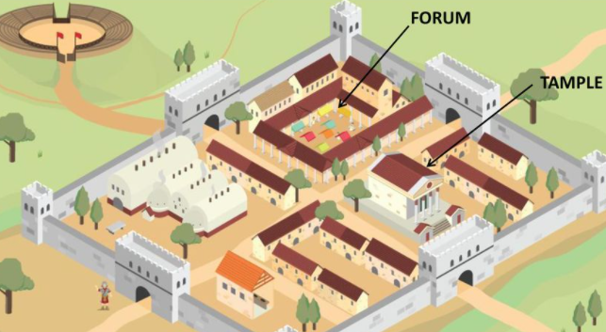
Roman Town
Towns were laid out in a grid. The blocks were called ‘insulae’. The market square was situated in the forum.



