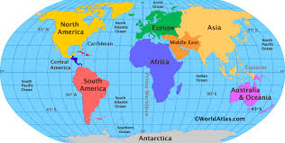
North and South America
North America is the 3rd largest continent and South America is the 4th largest continent.

Year 4 – Spring Term 2
Vocabulary
Weather | Is the temperature and conditions of the day like sun, rain or snow.
Climate | Is the average weather condition of a place over a long period of time.
Biome | Is a natural area of plants ad animals. The world is divided into lots of different biomes and they are all different depending on their climate.
Human features | Are things that have been built by people (man-made) like roads, houses and monuments.
Physical features | Are natural landmarks like seas, mountains and rivers.
Landmark | An object or feature of a landscape or town that is easily seen and recognisable from a distance.

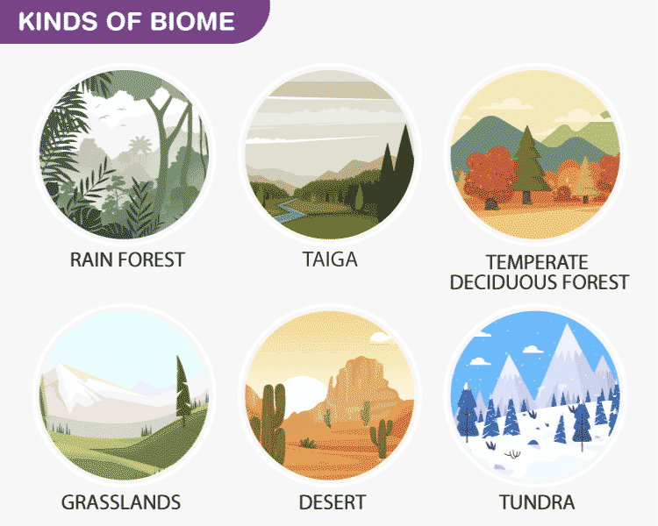
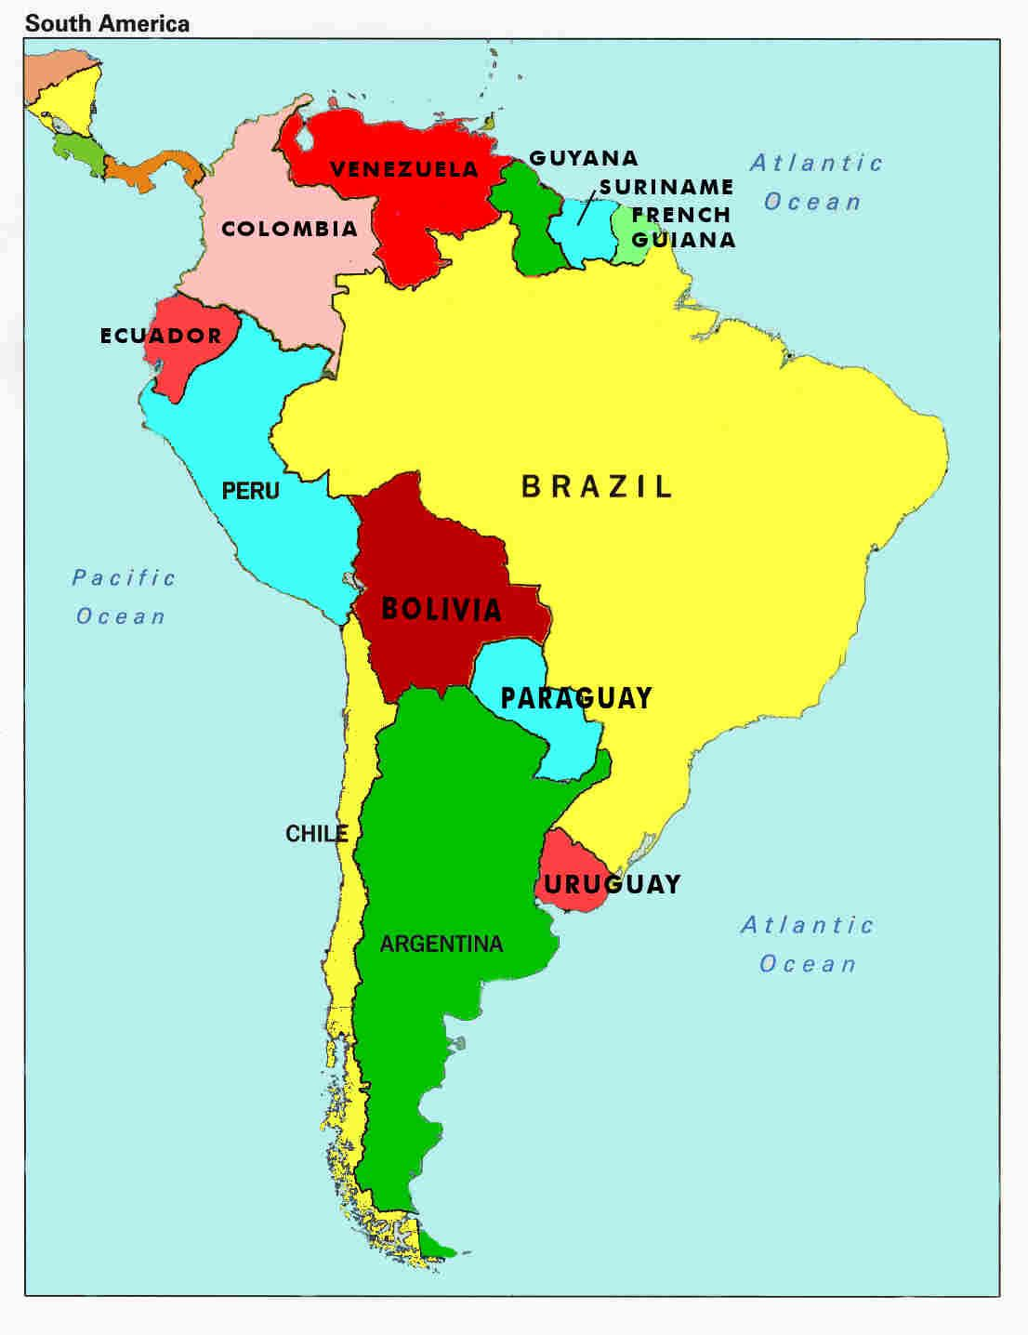
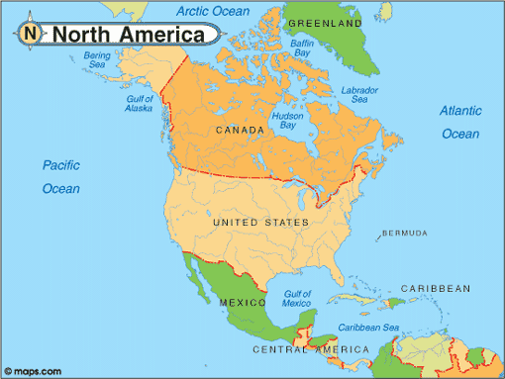
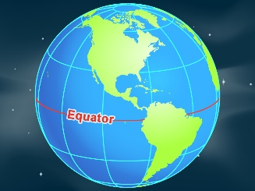
Climate Zones
The climate of a location is often linked to its location in the world. Places near the equator will have a hotter climate than places near the North and South Poles which will have a colder climate.
Types of Climate Zones:
Polar – Very cold and dry all year round.
Temperate – Cold winters and mild summers.
Arid – Dry and hot all year round.
Tropical – Hot and wet all year round.
Mediterranean – Dry, hot summers and mild winters.
Mountainous – Very cold, sometimes wet, all year.
What is a continent?
A continent is a very large landmass, usually separated by water or other natural features, like mountains. There are seven continents in the world.

