Year: 1 | Term: Spring 2
Seasons
Physical and human geography – focus on Long Eaton
Strand: Physical and human geography
g
Seasons
Physical and human geography

Key Vocabulary |  | Features
Winter | 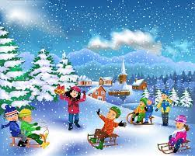 | -Cold temperatures  -Snow  -Hail  -Warm clothing  -Sledging  -Snowmen  -Short daylight hours
Spring | 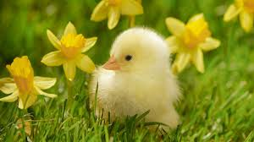 | -Daffoldils  -Blossom  -Buds become leaves  -Birds make nests  -Baby animals are born such as chicks
Summer | 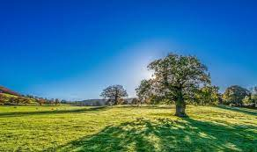 | -Hot weather  -Long daylight hours  -Trees have leaves on them  -Lots of insects and butterflies
Autumn | 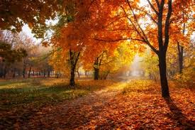 | -Leaves change colour and fall from trees  -Some animals hibinate eg. hedgehogs and frogs

Physical | Found in the natural environment
Mountain | 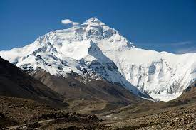
Wood | 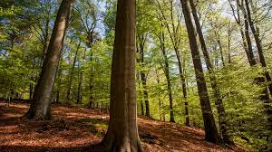
River | 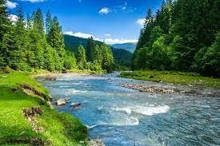
Beach | 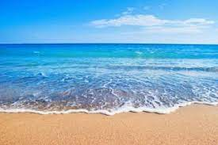
Lake | 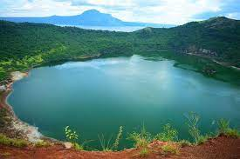
Volcano | 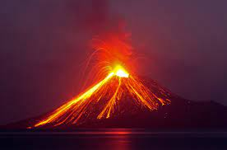
Human | Built by humans
House | 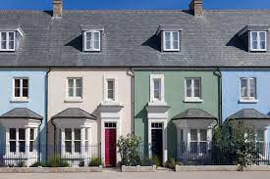
Factory | 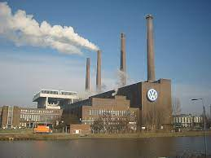
Bridge | 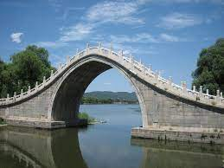
Pier | 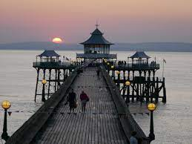
Shop | 
Canal | 

