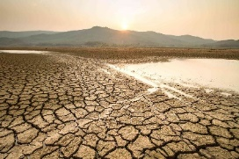
Global Warming
What is global warming?
Global warming is part of climate change and is concerned with the rising temperature of the global climate. It refers to the fact that the Earth’s temperature is getting hotter.
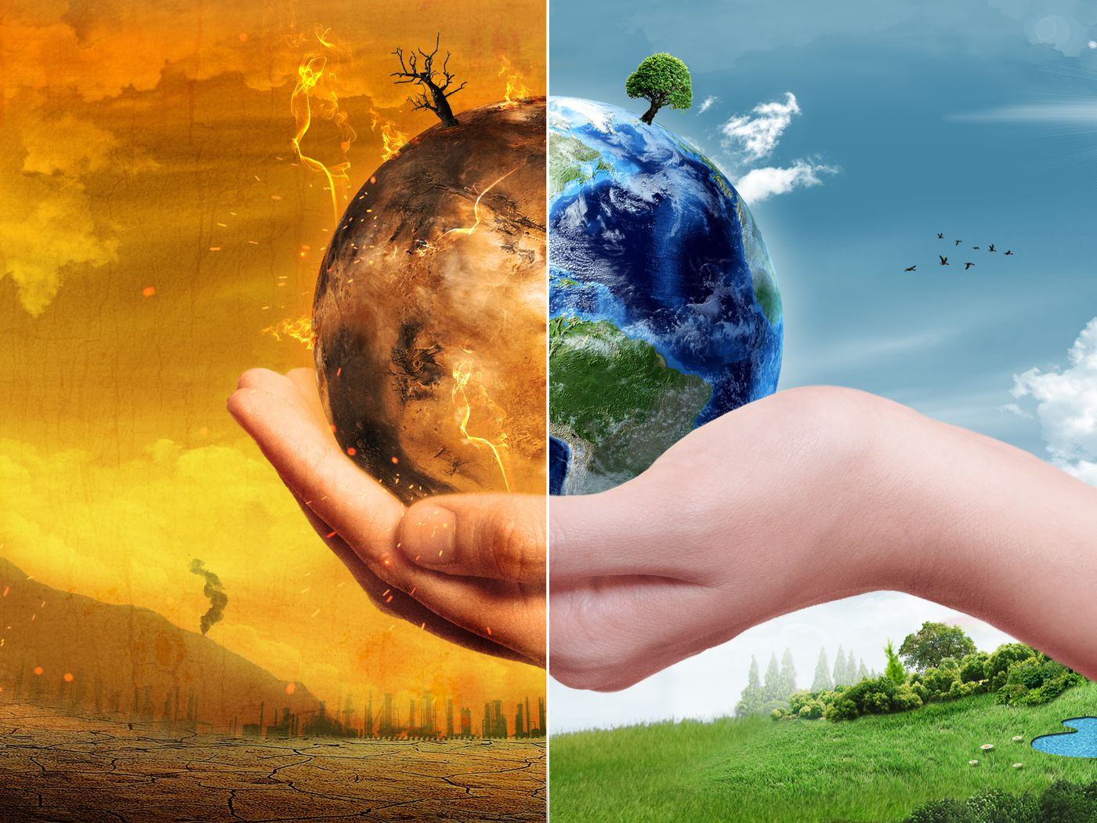
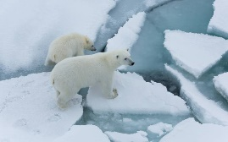
Year 4 – Geography Autumn 2


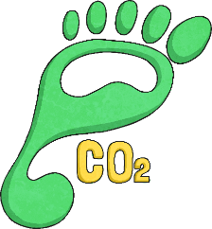

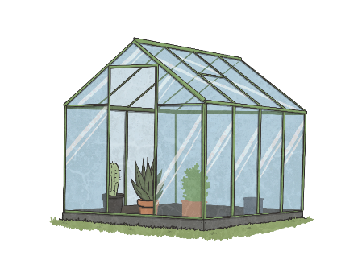
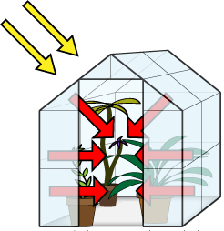
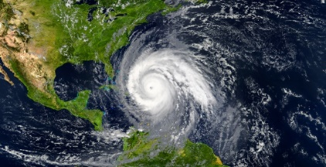
Our Carbon Footprint
The amount of carbon you produce as a result of your daily activities is known as your carbon footprint. Everything we do has an impact on the environment. If we made small changes to our daily routine, we could reduce our carbon footprint and have a positive effect on the environment.
Changes can include:
- The ways we travel
- Using less energy in the home
- Using less plastic
- Preparing meals with more fresh produce
- Reduce, reuse, recycle
The Greenhouse Effect
A garden greenhouse is made from glass or plastics which lets in sunlight and heat. Most of the heat cannot escape back out again and is trapped inside, making it a better environment for plants to grow.
Gases in the Earth's atmosphere have the same effect as the glass in a greenhouse, this is where they get their name.
What is causing global warming?
The main cause of global warming is an increase in carbon dioxide (CO₂) and other gases in Earth’s atmosphere. Carbon dioxide is one of a number of gases in the atmosphere called ‘greenhouse gases’. Other greenhouse gases include: methane, water vapour, nitrous oxide and ozone.
What effects does global warming have?
Some effects they have on the planet are:
- Drought
- Hurricanes
- Melting Ice caps
- Rising Sea levels
- Flooding
- Rising temperatures
- Changes in weather patterns

