
Key vocabulary
significant | Something that is great or important – worthy of attention.
event | A thing that happens or takes place, particularly of importance.
timeline | A representation of a period of time, on which important events are marked.
chronological | A record of events following the order in which they occurred.
culture | A pattern of behaviour shared by a society, or group of people.
Event linked vocabulary
space mission | A journey into space for a specific reason.
mankind | Human beings / the human race.
NASA | National Aeronautics and Space Administration. The organisation that is in charge of US science and technology to do with space.
World Cup | An international football competition held every 4 years.
hat trick | 3 goals scored by one player in the same football match.

In 1964, Roald Dahl wrote one of his most popular children’s books, Charlie and the Chocolate Factory. The book was illustrated by Quentin Blake.
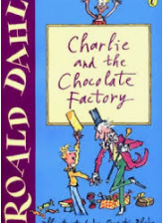
The British television audience peaked at 32.3 million viewers, making it the UK’s most watched television event ever. The words used by the commentator at the end of the game became famous: “They think it’s all over…it is now!”

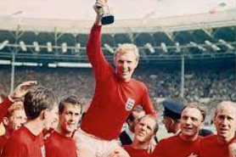

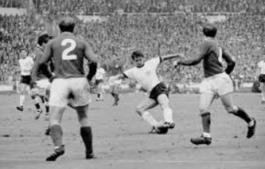
Significant event: 1966 World Cup

In 1966 England hosted the World Cup and won against Germany 4-2.
Geoff Hurst scored the first and only hat trick in a World Cup.
It was the first and only time England have won the World Cup.
Neil Armstrong
American astronaut
1930-2012
Pilot’s licence aged 15.
Joined NASA in 1962.
Flew over 200 different aircraft in his career.

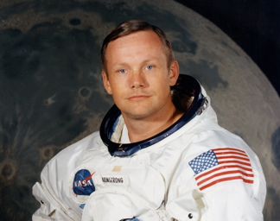
Significant event: 1969 the Moon Landing
After landing on the moon, they put an American flag in the ground, spoke to the President and then went to collect rocks and moon dirt for experiments. Armstrong’s famous first words as he left the spacecraft were: “That’s one small step for man, one giant leap for mankind”.
Armstrong was accompanied by crewmates Michael Collins and Buzz Aldrin.
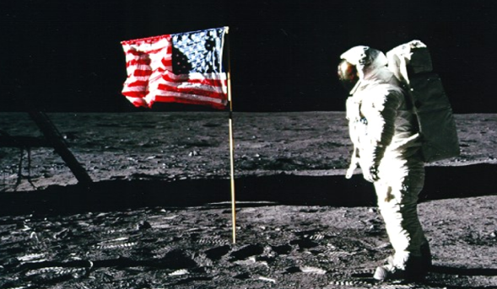
On July 20th 1969, Neil Armstrong became the first man to walk on the moon. The Apollo 11 space mission set off from Cape Kennedy, Florida in the United States.
Year 2 History Knowledge Organiser: The 1960’s Autumn 2

