Year: 1 | Term: Autumn 2
Geography
Strand: | Location and place knowledge – The UK

Key Vocabulary
United Kingdom | An island made up of England, Scotland, Wales and Northern Ireland.  (Also known as Great Britain).
Country | A place with its own government (people in charge). made up of cities, towns and villages.
Capital city | An important city where the government (people in charge) work in.
World map | A map that shows all of the countries in the world.

Key Knowledge
The United Kingdom is split up into 4 countries:
- England (where we live) - Scotland
- Wales - Northern Ireland
England – Capital city: London. Special day: St. George’s Day
Buckingham Palace. The London Eye
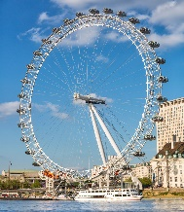
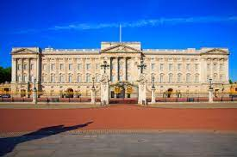
Longest river: River Thames Traditional food: Fish and chips
Tallest mountain: Scafel Pike Traditional drink: Cup of tea

Scotland - Capital city: Edinburgh. Special day: St. Andrew’s Day
Edinburgh Castle The Loch Ness Monster
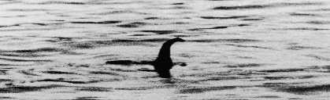
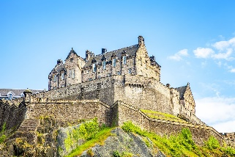
Longest river: The River Tay
Tallest mountain: Ben Nevis (tallest in all of UK!)
Traditional food: Haggis

Wales - Capital city: Cardiff. Special day: St. David’s Day
Millennium Stadium Snowdonia National Park
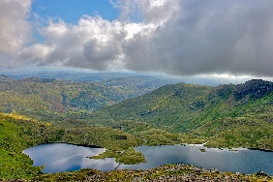
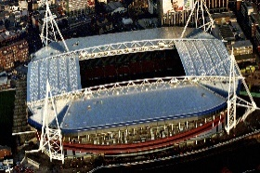
Longest river: River Severn (longest in all of UK!)
Tallest mountain: Mount Snowdon
Traditional food: Welsh cakes

Northern Ireland - Capital city: Belfast. Special day: St. Patrick’s Day.
Giant’s Causeway Carrick-a-Rede
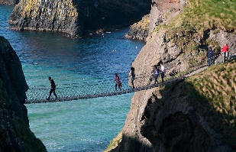
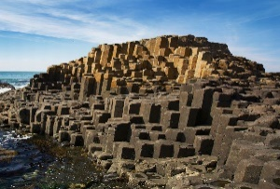
Longest river: River Bann
Tallest mountain: Slieve Donard
Tr Traditional food: Soda Bread Farl



