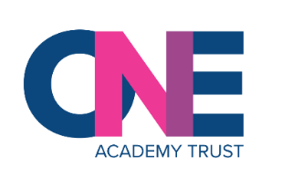
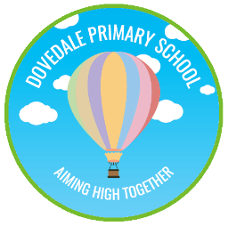
Dovedale Primary School
Science Curriculum
Strand-Light
 | EYFS | Year 1 | Year 2 | Year 3 | Year 4 | Year 5 | Year 6
Knowledge |  |  |  | Explore what happens when light reflects off a mirror or other reflective surfaces  - To know that we need light to see things.  - To know what light is.  - To know how mirrors work.  - To know how to use a mirror to reflect light.  - To know sources of light.  - To know that the sun is Earth’s source of light  Playing mirror games to help to answer questions about how light behaves.  - To know that light appears to travel in straight lines  - To know what reflection is.  - To know that light is reflected from surfaces. (check children know what is meant by a surface)  - To know how light is reflected off a surface(investigation)  Think about why it is important to protect their eyes from bright lights  (PSCHE link-sun safety).  - To know that light from the sun can be dangerous.  - To know what UV light is and its dangers.  - To know how we see when light enters our eyes.  - To know how to protect our eyes.  Know about shadows: look for, and measure, shadows, and find out how they are formed and what might cause the shadows to change.  - To know that dark is the absence of light.  - To know that shadows are formed when light is blocked by an opaque object. (investigation)  - To know we can find patterns in the way that the size of shadows change. |  |  | Build on the work on light in year 3, exploring the way that light behaves, including light sources, reflection and shadows.  - To know that light appears to travel in straight lines.  - To know how to show how light travels.  - To know that we see things because light travels from light sources to our eyes.  - To know and understand that objects are seen because they give out or reflect light into the eye.  - To know how fast light travels.  - To know that mirrors reflect light and help us see objects.  - To know that refraction changes the direction in which light travels.  - To know how a prism changes a ray of light.  - To know Isaac Newton is a famous scientist.  - To know Isaac Newton’s theory of light.  - To know how to explain why shadows have the same shape as the objects that cast them.  - To know scientific evidence has been used to support or refute ideas or arguments.  - To know about a range of phenomena including rainbows, colours on soap bubbles, objects looking bent in water and coloured filters.  - To know when and how some of these phenomena occur.
Skills | EYFS | Year 1 | Year 2 | Year 3 | Year 4 | Year 5 | Year 6
Skills |  |  |  | Recognise that they need light in order to see things and that dark is the absence of light.  - Define what is meant by the term’s ‘light’ and ‘dark.’  - Describe where light comes from using the terms natural, manmade and reflective sources.  - Categorise objects/items based on their light source.  Notice that light is reflected from surfaces  - Play mirror games to show how light behaves.  - Define what is meant by the term ‘reflection’.  - Use simple diagrams to show what happens when light reflects on different surfaces.  - Explain which surface reflects light the best.  Recognise that light from the sun can be dangerous and that there are ways to protect their eyes  - Identify the role of the sun in establishing day and night.  - Describe the benefits and dangers of the sun.  - Explain ways we can protect our body and our eyes from the sun.  Recognise that shadows are formed when the light from a light source is blocked by an opaque object  - Explain how light travels and how shadows are formed.  - Use light sources to test which objects let light through and which objects block light.  - Classify objects based on whether they are opaque, translucent, or transparent.  Find patterns in the way that the size of shadows change  - Set up simple practical enquiries.  - Make careful observations throughout the day.  - Use simple diagrams to present data. |  |  | Recognise that light appears to travel in straight lines  - Name light sources.  - Demonstrate how light moves in straight lines.  - Draw a diagram that shows how light travels in straight lines from a light source to our eyes (or from a light source to an object and then into our eyes).  Use the idea that light travels in straight lines to explain that objects are seen because they give out or reflect light into the eye  - Explain how light is reflected.  - Observe and draw angles of incidence and angles of reflection.  - Apply your knowledge to solve light problems.  Explain that we see things because light travels from light sources to our eyes or from light sources to objects and then to our eyes  - Complete and investigation using filter to explore how we see colour.  - Write an explanation of how we can see colour using the words: absorb and reflect.  - Apply your knowledge to create a secret message that can only be read through a colour filter.  Use the idea that light travels in straight lines to explain why shadows have the same shape as the objects that cast them  - Explain how shadows are formed.  - Explain why shadows are the same shape as the objects that cast them.  - Apply this knowledge to take part in a shadow puppet theatre show.
Working Scientifically | EYFS | Year 1 | Year 2 | Year 3 | Year 4 | Year 5 | Year 6
Working Scientifically |  |  |  | Looking for patterns in what happens to shadows when the light source moves or the distance between the light source and the object changes.  - Plan and set up a simple investigation about the way shadows change.  - Observe patterns in the way shadows change.  - Explain the patterns that change shadows. |  |  | Deciding where to place rear-view mirrors on cars  Designing and making a periscope and using the idea that light appears to travel in straight lines to explain how it works.  - Investigate what happens when we shine a ray of light through a prism.  - Explain what the investigation tells us about the visible spectrum.  - Make a colour wheel and discuss what this shows us about the visible spectrum.  GD: investigate the relationship between light sources, objects and shadows by using shadow puppets.  Extend their experience of light by looking a range of phenomena including rainbows, colours on soap bubbles, objects looking bent in water, and coloured filters (they do not need to explain why these phenomena occur).  Carry out investigations to observe refraction.  Report the findings from my own investigations.  Define refraction using scientific language and diagrams.
 | EYFS | Year 1 | Year 2 | Year 3 | Year 4 | Year 5 | Year 6
Vocabulary |  |  |  | Shadows, reflection, light source, opaque object, |  |  | Phenomena,  Coloured filters,  Periscope,
 | EYFS | Year 1 | Year 2 | Year 3 | Year 4 | Year 5 | Year 6
Experiments ideas/ investigations |  |  |  | Making a sundial to learn about shadows and time.  Making shadow puppets.  Exploring the shadows of different objects. |  |  | Modelling light using different objects investigating how light travels in straight lines.  Refraction: Investigation 1 ‘Incredible Images’  Investigation 2: ‘Amazing Arrows’  Investigation 3:  ‘Fancy Filters’
Light
What children need to know:  - that light travels in straight lines  - that objects are seen because they emit light (sources) or reflect light into the eye  - that we see things because light travels from light sources to our eyes or from light sources to objects and then (is reflected) to our eyes | Common misconceptions  Often children will think that:  - sight is purely an active human process ‘I am looking at something, which is why I can see it’ or that eyes give out a form of light to enable us to see  - reflective surfaces emit light  - only shiny surfaces or water reflect light  - opaque objects do not reflect light  - opaque surfaces give out colour or ‘darkness’ | 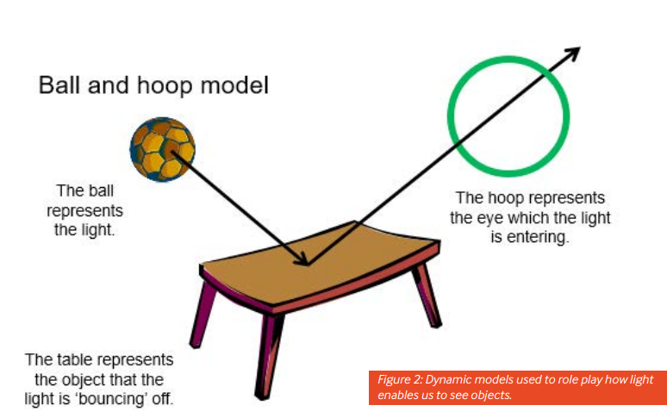  UNDERSTANDING HOW WE SEE OBJECTS

