Summer Term:1 Spelling Lists.
No spelling tests on 15/5 due to SATs and 22/5 due to an INSET day.
Tested on 17th April  (Step 28) | Tested on 24th April  (Step 29) | Tested on 1st May.  (Step 35 ). | Tested on 8th May.  (These spellings are not on Spelling shed)
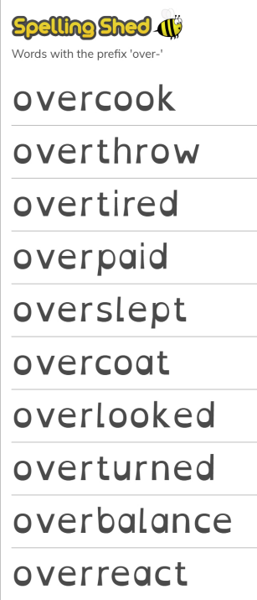 | 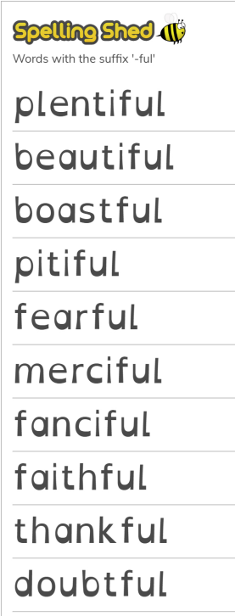 | 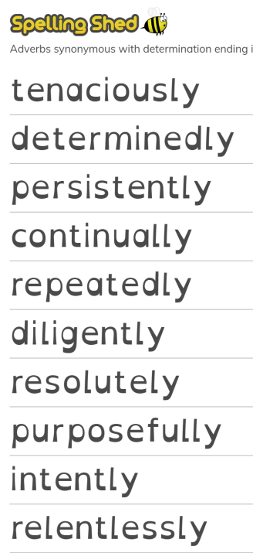 | receipt  seize  weird  neighbour  protein  deceit  deceive  ceiling  receive  resign

