Year 6 Spellings. Spring term 2. 2026.
Tested on 27th February | Tested on 6th March | Tested on 13th March | Tested on 20st March | Tested on 27th March
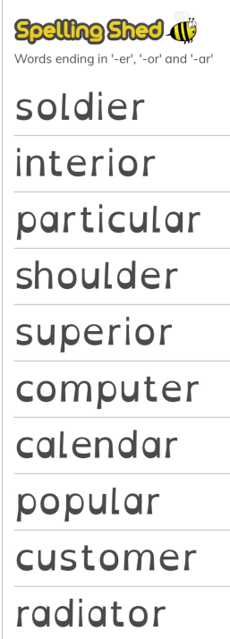 | 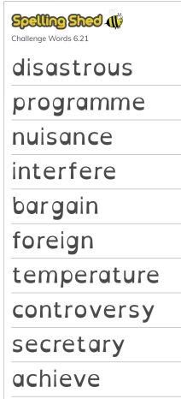 | 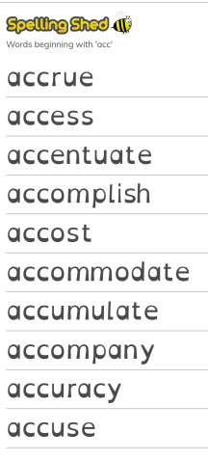 | 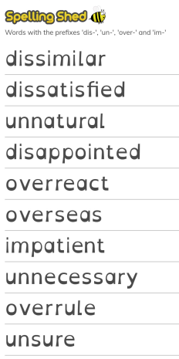 | 

