Year: 6 | Term: Spring 2
Key question: Is it better to express your religion in arts and architecture or in charity and generosity?
Strand: Expressing | Religious focus: Islam and Christianity

Key Vocabulary:
Spiritual | Relating to people's thoughts and beliefs, rather than to their bodies and physical surroundings.
Sacred | Something that is sacred is believed to be holy and to have a special connection with God.
Charities | 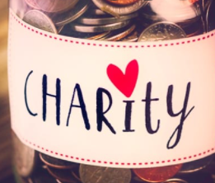  an organisation which raises money in order to help people who are sick or very poor, or who have a disability
Art | paintings, sculpture, and other pictures or objects which are created for people to look at and admire or think deeply about
Believers | If you are a great believer in something, you think that it is good, right, or useful.
Architecture | 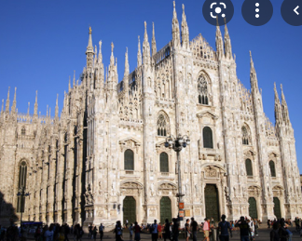  The architecture of a building is the style in which it is designed and constructed
Scriptures | any book or body of writings, especially when regarded as  sacred by a particular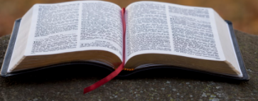 religious group
Poverty | Poverty is the state of being extremely poor
Secular | You use secular to describe things that have no connection with religion.

Key Knowledge:

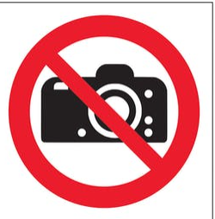
Muslims do not believe they should ever depict their God in any way. Drawing their God is deemed to be highly offensive to them and we should respect their viewpoint on this.

Cathedrals have been created, often over many hundreds of years, to make space for people to worship God.
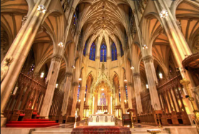

Christians follow the teachings of Jesus about how they should act out of love, help others, have fellowship and be generous
There are about 50 000 church buildings in the UK. •
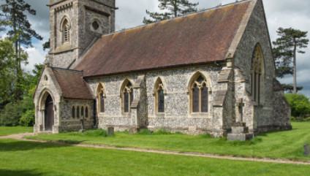

There are many Christian & Muslim charities which help those in poverty around the world.
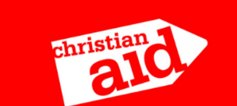

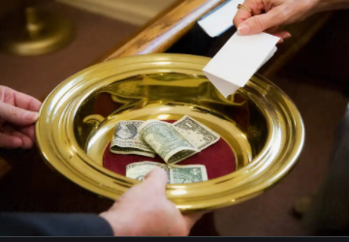
Christians believe that they should give 10% of their income to their church, so they can spend it telling more people about their religion.
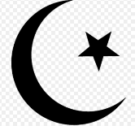
Symbols of this unit:

What should I already know?
How people from different religions express their beliefs through prayer and festivals.
Zakat is one of the 5 pillars of Islam and is linked to the belief that Muslims should donate money to charity.
Important Places
Mosques, Churches, Cathedrals

