PSCHE – Personal, Social, Citizenship, Health and Economic Education
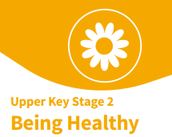
Core Theme: Health and Wellbeing
Year: 5 | Term: Autumn 1

Key Knowledge
5 ways of well-being (physical, mental and emotional health):
The benefits of a healthy lifestyle are:  More energy  Essential nutrients for growth/repair  Healthy weight  Prevent/fight infections  Strong bones/muscles  Better mental health  Better quality of sleep  Helps to make friends | Sun Safety  Reduce the risk of sun damage:  Wear sun cream, drink plenty of water, wear a hat, wear sunglasses, seek shade and avoid sun exposure between 11am-3pm.  We need to stay safe to:  Protect from harmful UV rays  Avoid sunburn  Protect our eyes  Avoid dehydration
Sleep  A lack of good quality sleep can affect weight, mood and ability to learn. | Looking after my teeth…  Prevents tooth decay  Prevents gum disease  Prevents bad breath  Keeps teeth white
Talking helps! Who can I talk to?  Miss Berrington  Mr Almeida  Any adult in school  Any trusted adult at home | Habit  Routines or behaviour that are repeated. These can be good e.g. regular exercise or bad e.g. too much screen time. It can be difficult to break a habit.

Key Learning
H1 - Know what positively and negatively affects my physical, mental and emotional health.
H1 – Recognise the characteristics of an active, healthy lifestyle and the importance of regular exercise.
H2 - Understand the concept and benefits of a balanced healthy lifestyle. Explore the risks associated with an inactive, unhealthy lifestyle.
H1 – Understand the importance of sufficient, good quality sleep.
H1 – Understand the importance of dental health.
H1 – Understand what is safe and unsafe exposure to the sun, why we need to stay safe and how to reduce the risk of sun damage.
H1 – Know how and when to seek support including which adults to speak to in school,
H3 – Recognise opportunities and develop the skills to make my own choices about food, understanding what might influence my choices.
H3 - Identify how to make real, informed choices.
H4 - Recognise how images in the media do not always reflect reality.
H5 - Set goals that will challenge me.
H16 - Explore what is meant by the term habit and why habits can be hard to change.

What I have learnt already
H1 - Explore what affects my physical, mental and emotional health.
H1 – Recognise the characteristics of an active, healthy lifestyle.
H1 – Recognise the importance of dental health
H1 – Know about safe and unsafe exposure to the sun
H2 – Begin to understand the concept and benefits of a balanced healthy lifestyle
H2 - Identify how to make real, informed choices
H3 – Understand what is included in a balanced diet
H3 - Understand what may influence our choices.
H5 - Set goals.
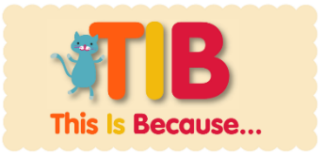
We need to learn how to keep our bodies healthy so we can live a happy and healthy life.
Our PSCHE Ground Rules…
- We listen to each other.
- We show respect.
- We support each other.
- We ask questions if we want to.
- We know we can talk to any adult in school if we want to talk or need help.

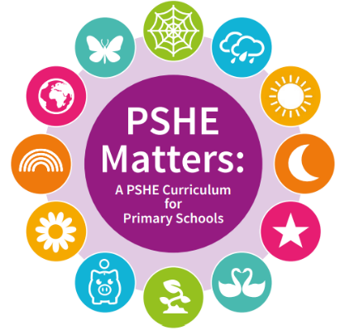
Key Vocabulary
Physical health | Mental health | Balanced lifestyle
Choices | Media | Reality
Goals | Habits | Risks
Dental health | Obesity | Smoking
Stigma | Tooth decay | Wellbeing

