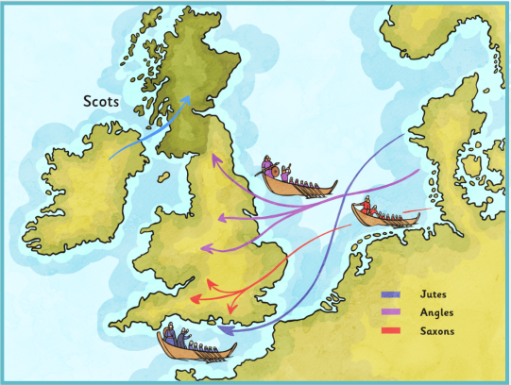

Who were the Scots?
The Gaelic speaking Scotti who came from Ireland were descendants of the Picts who had earlier invaded Ireland, around 200AD. Historians believe that these Irish Scots invaded and claimed land in Scotland in the 4th and 5th centuries. However, some historians
now believe that the Scots had always lived in Scotland.

The Scots divided the land in Scotland into 4
separate kingdoms which were named Dal Riata,
Pictland, Strathclyde and Bernicia.

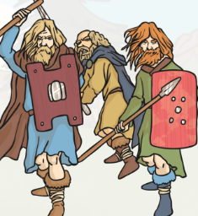

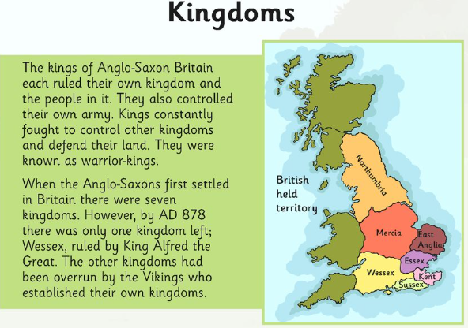

What sources do historians have to use?
The Saxons lived in a period called the dark ages. The time between the Romans leaving and the Normans is known as this because not much evidence exists. However, an important manuscript called the Anglo Saxon Chronicle was written to document things such as farming, laws, wars and battles. They were mostly written in the 9th century, during the reign of King Alfred the Great. The chronicles are written in Old English, the oldest form of the English language. Some historians are very careful when they interpret what was written.

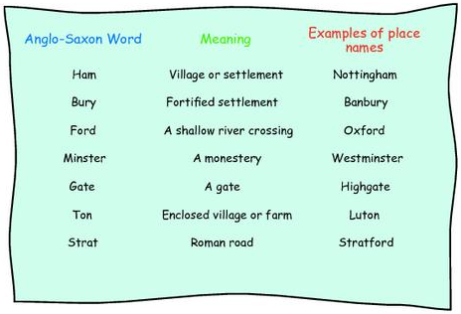
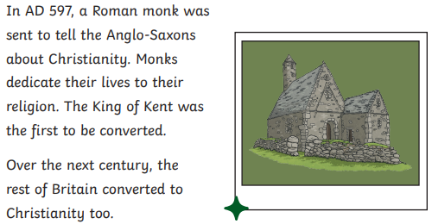
The Legacy of the transition from paganism to Christianity
Many churches, mainly constructed from wood were built all over England. Magic water became Holy water. Abbeys and monasteries were built. It changed our landscape forever.

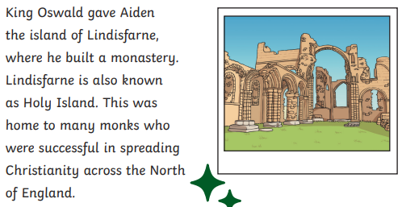

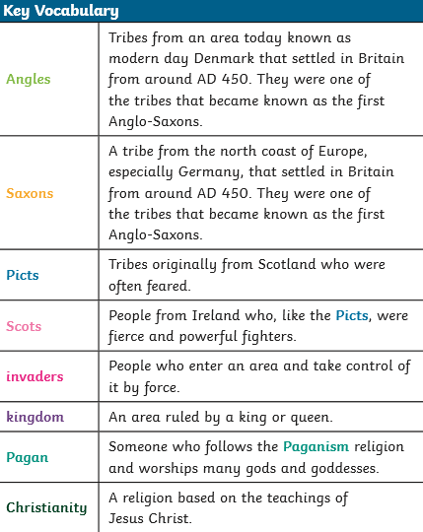

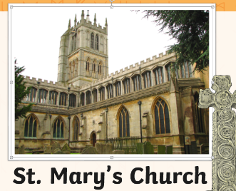

300-400 AD | Scots invade Scotland. (What the Romans called Pictland.)
410 | Romans leave Britain
449 | Hengest & Horsa invited to help defend England.
450 | Invasions begin from the Angles/ Saxons/ Jutes
595 | St Augustine travels to Britain to convert Saxons to Christianity.
730 | Bede writes A history of the English church and people.



