PSCHE – Personal, Social, Citizenship, Health and Economic Education
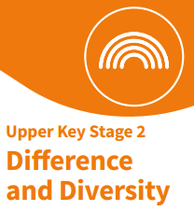
Core Theme: Relationships

Year: 5 | Term: Autumn 2

Key Knowledge
We live in a diverse world. People can be similar or different through their personality, interests, gender identity, sexual orientation, age, culture, religious beliefs, likes/dislikes etc.
Even though everyone is different, we are all equal.
Discrimination is treating someone differently based on their differences e.g. age, religious beliefs, ethnicity, sexual orientation or disability.
Stereotyping is a fixed or set belief about a group of people. Stereotyping can be negative/unfair.
Sex – physical differences between people who are male or female.
Gender Identity – how someone feels about their gender. E.g. some people may identify as a boy or a girl. Others may find neither of these terms feel right for them
Sexual Orientation - who someone feels physically and emotionally attracted to. This can be romantic or emotional attraction, or both.
Our PSCHE Ground Rules…
- We listen to each other.
- We show respect.
- We support each other.
- We ask questions if we want to.
- We know we can talk to any adult in school if we want to talk or need help.

Key Learning
R10 – Identify how to listen and respond respectfully to a wide range of people even when they are very different to me and understand the importance of this.
R13 - Recognise a range of factors that make people the same or different but understand everyone is equal.
R14 - Understand the nature and consequences of discrimination.
R16 - Recognise and challenge stereotypes. Know that stereotypes can be unfair, negative or destructive.
R17 – Understand the correct use of the terms sex, gender identity and sexual orientation

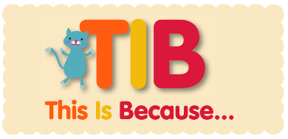
What I have learnt already
R10 - Identify how to listen and respond respectfully to a wide range of people.
R13 - Recognise simple similarities and differences between people but understand everyone is equal.
R14 – Recognise the nature and consequences of discrimination.
R16 - Recognise and challenge stereotypes.
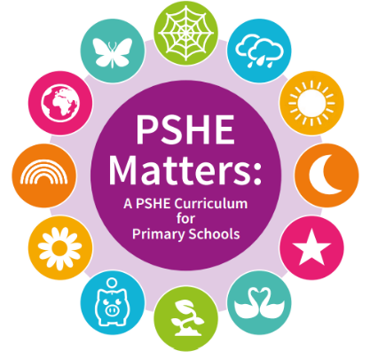
We need to understand that everyone is different in many ways and that this is ok. We treat everyone with respect.
Key Vocabulary
differences | diversity | equal
discrimination | consequences | stereotypes
sex | gender identity | sexual orientation

