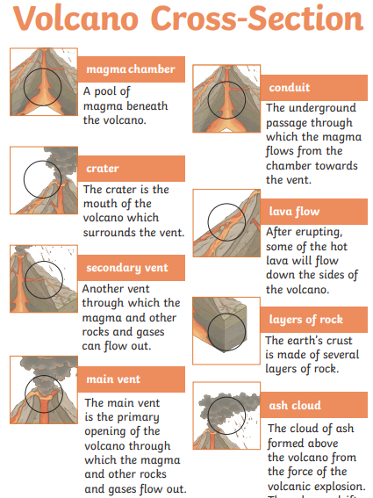
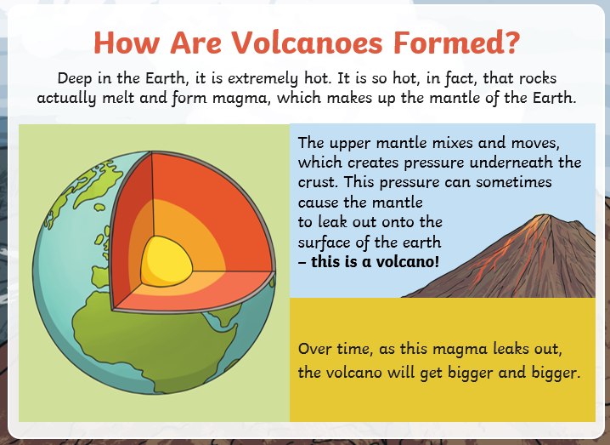
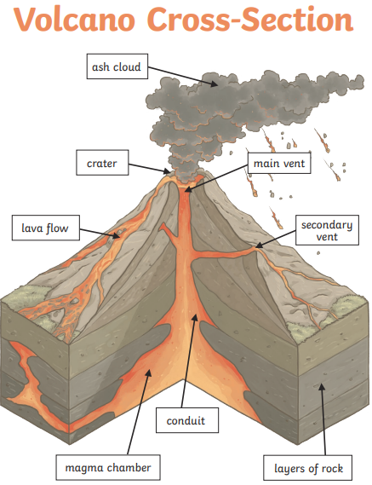

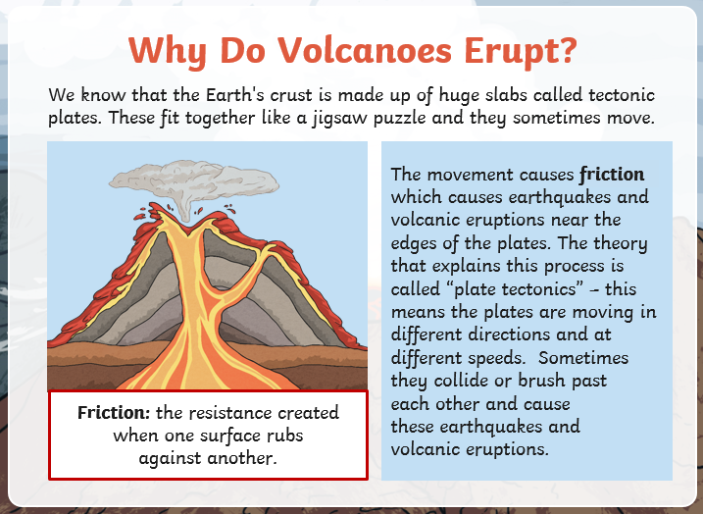

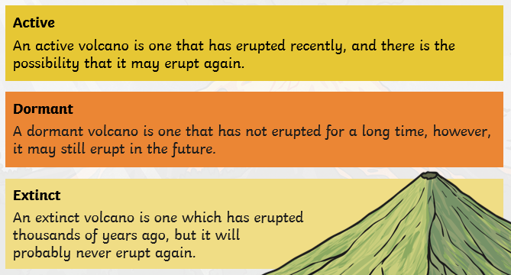

Can volcanic eruptions, earthquakes and tsunamis be predicted?
Earthquakes and tsunamis are extremely difficult to predict. Scientists can monitor active earthquake zones for seismic activity using sensitive equipment. (tiltmeters) Recording equipment is also used to measure earth tremors.
Scientists can monitor volcanoes to estimate when they are likely to erupt. They measure things like temperature and the gases being emitted by a volcano. (Sulphur dioxide increases during an eruption.) However, if the eruption is triggered by an earthquake, it is much harder to predict.

An eruption can have positive and negative effects…
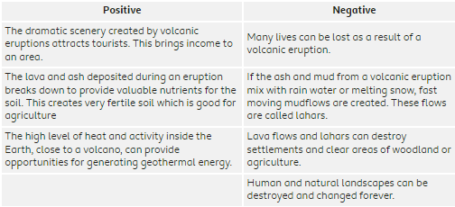

Most of the world’s volcanoes are located around the Ring of Fire in the Pacific Ocean


