Types of Land & building use: | Examples we find as we learn…
Residential
(Where people live- residents)
Retail
(Buildings for buying & selling goods)
Professional/ commercial
(offices / outlets for companies)
Industrial and storage
(factories & manufacturing)
Leisure/ recreational
(What does the general public do to relax?)
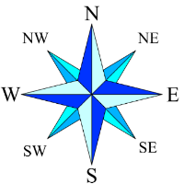
Geography Knowledge Organiser
Compass
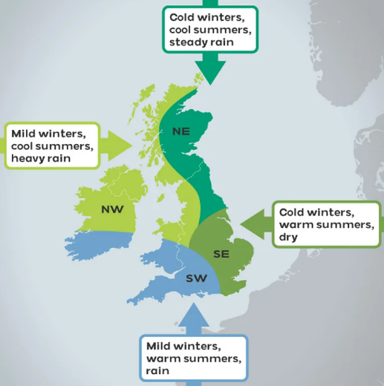

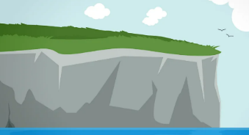
-Coasts have lots of different features, such as beaches, cliffs,
islands, caves and mudflats.
-The UK is surrounded by the North Atlantic Ocean, the North Sea,
Irish Sea, and the English Channel.
-It is a maritime nation, which means that the lives of people living here
are connected with the sea.
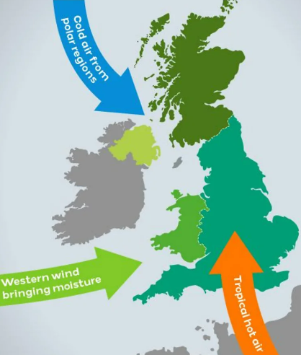

-Weather is the day-to-day conditions of the atmosphere.

-Climate is a long-term pattern of weather which happens over many years in a specific area.
-The UK is in a temperate climate zone, which means that there are four seasons.
The winters are cool and wet, and the summers are warm and wet; temperatures usually
stay mild with rare extremes.
The climate of the UK is mainly influenced by: ocean currents, cold air from polar regions
and westerly winds bringing moisture.

City of Sheffield  County: South Yorkshire  England's fifth-largest city.  Population: 582.500  River Don | 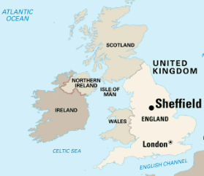 | - Sheffield was very important during the Industrial Revolution. Many new technologies were invented here. In the 1800s, the city's famous cutlery business grew a lot. Once known as the Steel City.  - After the 1970s, the steel and coal mining industries faced challenges. But in the 2000s, Sheffield has been rebuilt and improved, just like other British cities. It is one of the greenest cities in Europe.  - It sits on the edge of the Peak District National Park  - The central area is home to major shopping streets, green spaces like the Peace Gardens, and historical architecture including the City Hall.
City of Glasgow  County: Formerly Lanarkshire  Scotland’s biggest city.  Population: 620,000  Clyde River | 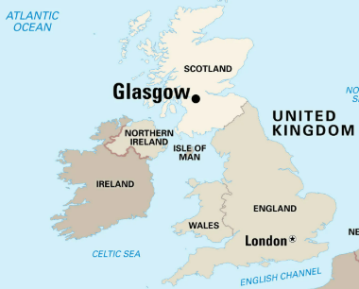 | - Glasgow became a great trading centre by the 1700s. The Clyde was deepened so boats could sail farther into the city. The Industrial Revolution brought many different kinds of manufacturing, including coal mining, shipbuilding, and soap making, to Glasgow.  - Glasgow has undergone many changes in the past 100 years. The factories declined in the 1900s, but the city developed new businesses, especially in the service sector, by the early 2000s. The United Nations group UNESCO recognised Glasgow as a special city of culture in 2008.  - The city hosts many musical and cultural events every year.
City of Milton Keynes  County: Buckinghamshire  England's 17th-argest city.  Population: 264,349  River Ouzel & River Great Ouse. | 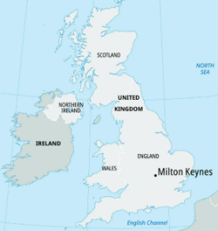 | - Developed as a "new town" in the 1960s to relieve housing pressures in London, it was granted formal city status in 2022.  - The government wanted a city that felt more natural and human-friendly. To avoid traffic jams, they created a grid of main roads about 1 km apart. The areas between these roads were allowed to grow more naturally. There are also many paths for walking and cycling.  - Unlike some older new towns, they avoided building tall apartment blocks. Most buildings outside the city centre are no taller than three storeys.

