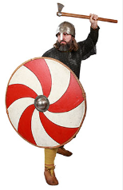
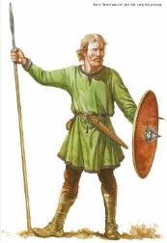


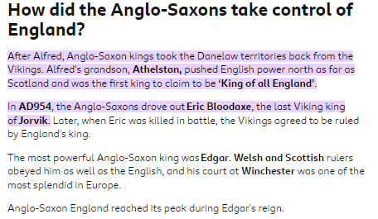
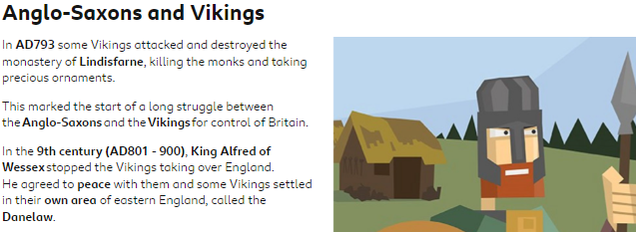



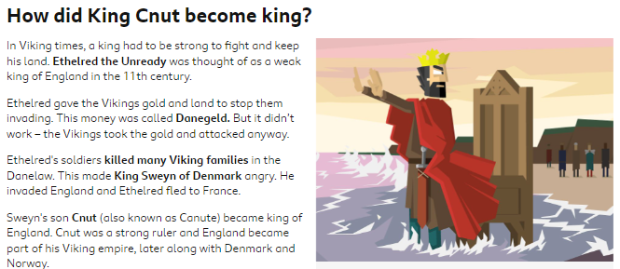
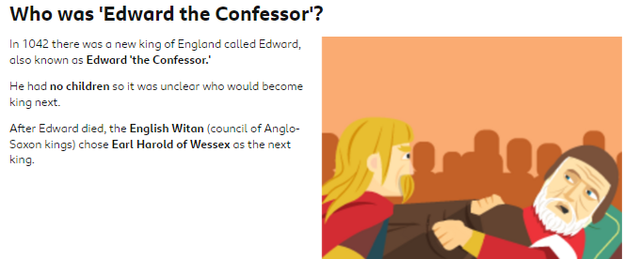

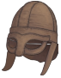
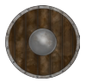

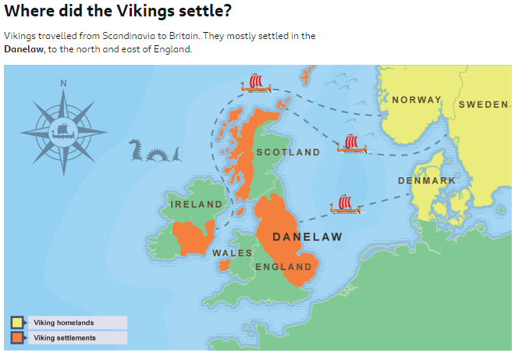
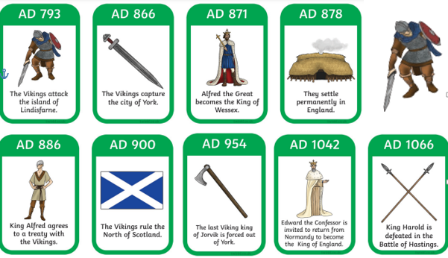

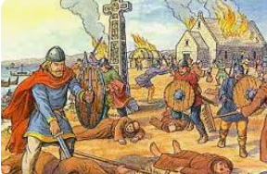
Viking Vocabulary
invade | To attack/ occupy by force.
longship | long, wooden ship used by the Vikings
monastery | place where monks live and worship
Lindisfarne | Lindisfarne, also known as Holy Island, was one of the first landing sites of the Vikings.
pillage | steal in a violent way
plunder | Stolen goods
Danes | what the Anglo-Saxons called a Viking invader
Danelaw | area of England under Viking rule


