Year: 3 | Term: Summer 1 | Focus: Art
Greek pot in clay
Focus: Sculpture

Sculpture – vocabulary
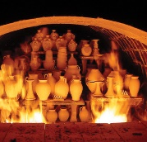  Ceramics | Objects that have been made from a material that has been permanently changed after it has been heated.
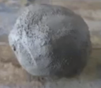  Clay | Mouldable material found under the ground and is made of tiny rock as well as mineral particles.
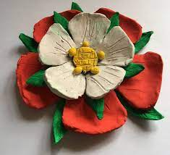  Sculpture | A 3-dimensional piece of art which has been made by sculpting (carving or shaping) using materials such as clay.
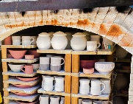  Kiln | Type of oven used to heat clay ceramics and harden the material.
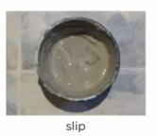  Slip | Liquid paste used to fix two clay pieces together. Make by adding water to clay and mixing.
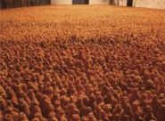  Art Installation | Large scale artwork designed to fit a specific place.
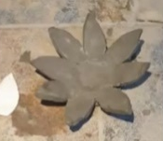  Template | Card cut into a shape that can be placed on the top of clay to cut the clay into a particular shape.
Significant and local sculpture trails
Installation of red poppies staged at HM Tower of London in 2014 by artist Paul Cummins and designer Tom Piper. The poppies have since travelled as far afield as Australia, some taken to war memorials in memory of those who lost their lives in World War I. | Blood Swept Land and Seas of Red  by Paul Cummins (2014)  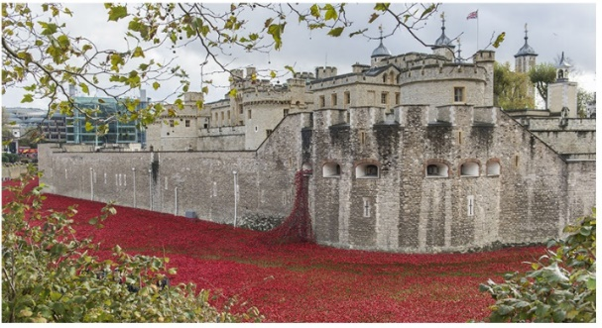
In 2020, around 10 colourful owls were installed in and around Nottingham city centre as part of a public arts trail and crack a secret code by finding hidden letters on each owl. | Nottingham Wise Owl Walk (2020)  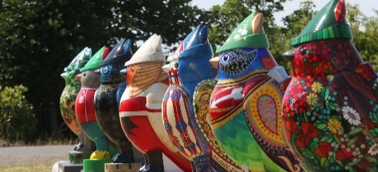  Hoodwinked by various artists
One of a number of different installations based on a “fields” theme using 40,000 small figures in a particular space. It celebrates community, individuality and togetherness. | 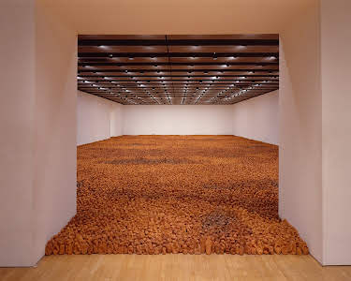  Field for the British Isles by Antony Gormley (1993)
Tools: rolling pin, chisels, spatulas, shapers, strip and loop tools
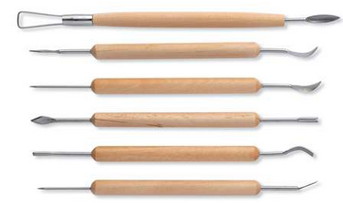
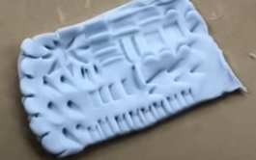
Sculpting Techniques:
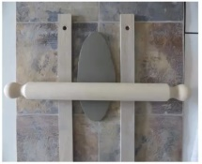  Slabbing | Involves rolling out clay so that it is flat. The clay is cut into pieces which can be used as tiles or joined together to create a 3D form.
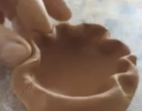  Pinching | Shaping clay by pressing and pinching out a ball of clay using your thumb and fingers.
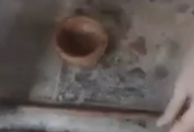  Coiling | Shaping clay by rolling in into “sausage-shaped” coils which can be joined and blended together.
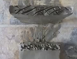  Scoring | Making shallow grooves in the clay in order to join two different pieces together.
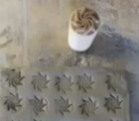  Impressing | Making shallow indents into clay in order to create surface patterns and designs.  Impressing tools include: forks, stamps.
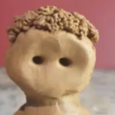  Free modelling | Working by hand to change the shape of soft materials such as clay.
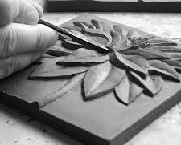  Carving | Cutting away pieces of wood, stone or clay to create a particular shape of form.

