Year: 3 | Term: Summer 1
Key question: 2.1 – What do different people believe about God?
Strand: Believing | Religious focus: Christianity. Islamic & Humanist

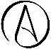
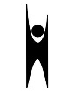
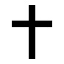
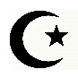
Sacred links:
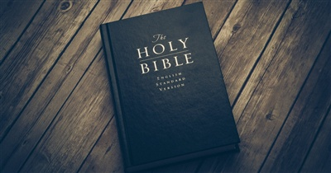
Bible – Sacred text for Christians
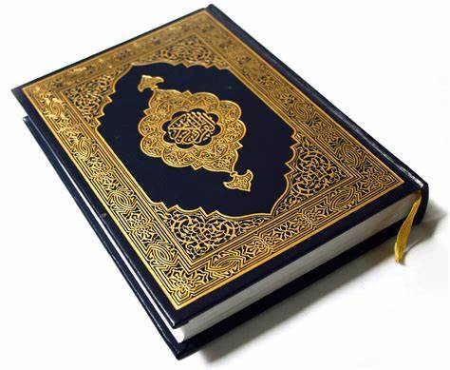
Qur’an – Sacred text for Muslims.
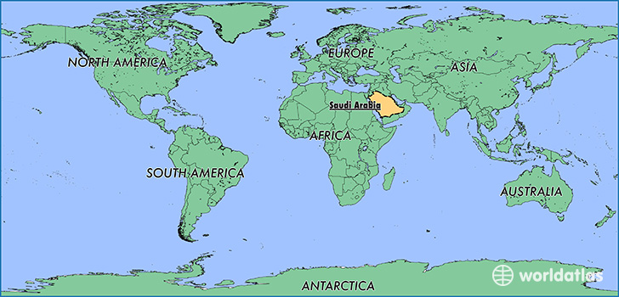
Saudi Arabia on a world map. (yellow)
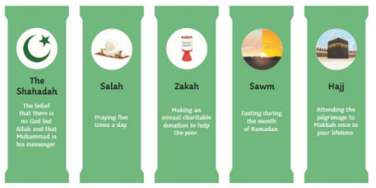
The Five Pillars of Islam.
Humanist
Atheist
Non-Religious Symbols

Islamic
Religious Symbols:

Christianity

Key Vocabulary
Religion | A way of faith and worship.
Beliefs | Trust, faith or confidence in someone or something.
Truth | The quality or state of being true.
Opinion | A view or judgement formed about something, not necessarily based on fact or knowledge.
Religious | Relating to or believing in a religion.
Non-religious | Not relating to or believing in a religion.
God | A spirit worshipped as having power over nature or human fortunes.
Christians | A person who has received Christian baptism or is a believer in Christianity.
Trinity | The three persons of the Christian Godhead; Faither, Son and Holy Spirit.
Moses | The Hebrew prophet who led the Israelites to freedom out of Egypt slavery.
Islamic | Relating to Islam and the Islamic world.
Muslim | A follower of the religion of Islam.
Allah | The one and only God in Islam.
Monotheistic | A view relating to or characterised by the belief that there is only one God.
Prophet Muhammad | An Arabic religious, social and political leader and the founder of Islam.
Five pillars | Basic acts in Islam, considered mandatory by believers and are the foundation of Muslim life.
Humanism | A view or outlook thought to value the importance of humans rather than supernatural matters.
Humanist | A folder of the principles of humanism.
Humanity | The quality of being humane and humans working together collectively.
Atheist | A person who disbelieves or lacks belief in the existence of God or gods.
Key Knowledge
Christians believe in God as a trinity which makes reference to the unity of God the Father, God the Son and God the Holy Spirit.
Christians believe that God provides many benefits to their lives by giving them love, acting as a father, providing light in their life and by being the creator of life and the universe.
Moses is a central figure in Judaism as he was the prophet who led the Hebrew slaves out of Egypt. Moses formed a special relationship with God and is seen to be an important religious figure in both Christianity and Islam because of his vital role in communicating God’s laws.
Muslims believe that Allah (God) created the world and he created human beings to help maintain harmony in the natural world.
In Islam, God is believed to have 99 names in the Qur’an. Muslims refer to this as the 99 beautiful names of Allah (God.) These names are written in the Qur’an in Arabic.
Muslim beliefs are focused around the Five Pillars of Islam: declaration of faith, obligatory prayer, compulsory giving, fasting in the month of Ramadan and pilgrimage to Mecca.
Whilst Christians and Muslims both believe in Gods the two religions are in contrast/difference of one another. Christians believe in the God as a trinity (three people) whereas Muslims believe in the oneness of Allah.
Religious people believe God guides their lives and provides the teachings around right and wrong. Non-religious people follow simple codes for living to live a good life by spreading kindness, es

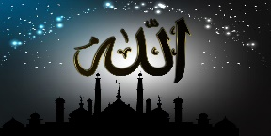
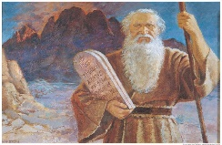
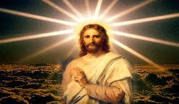
Jesus Christ Moses Allah
Key figures in religion.
(these are people’s representations of the key figures as no-one has seen these figures).

