Autumn 2 Spellings
Week 1  Tested on 7th November | Week 2  Tested on 14th November | Week 3  Tested on 21st November | Week 4  Tested on 28th November
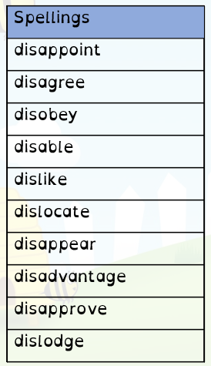 | 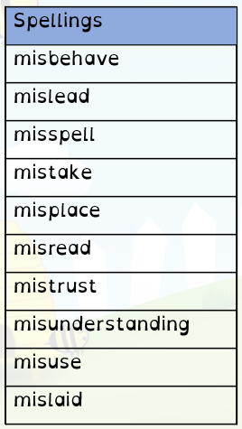 | 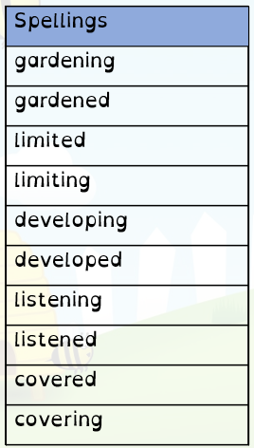 | 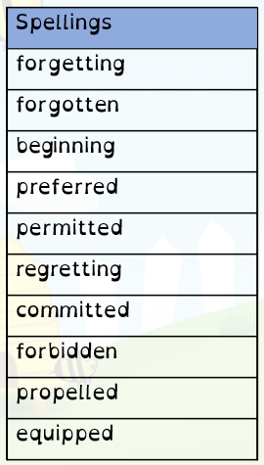
Week 5  Tested on 5th December | Week 6  Tested on 12th December | Week 7  Tested on 19th December
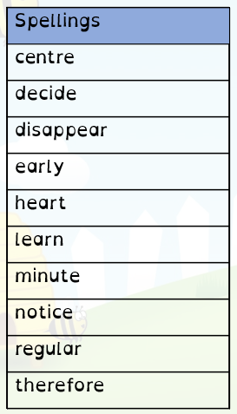 | 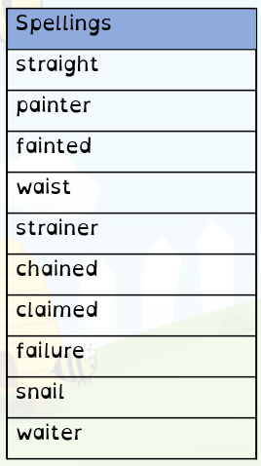 | This week you can practice any spellings your child might have struggled with this half term, or take this opportunity to try these spelling words in sentences. There will be no spelling test this week.

