Autumn 1 Spellings
Week 2 – Tested 12th September | Week 3 – Tested 19th September | Week 4 – Tested 26th September | Week 5 – Tested 3rd October
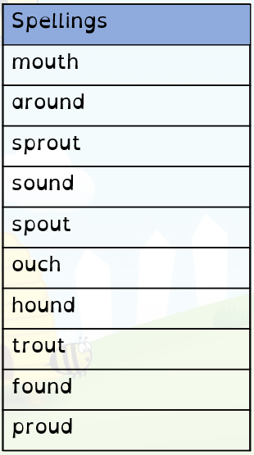 | 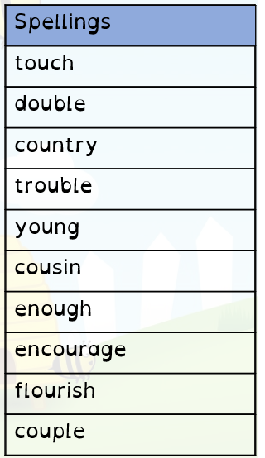 | 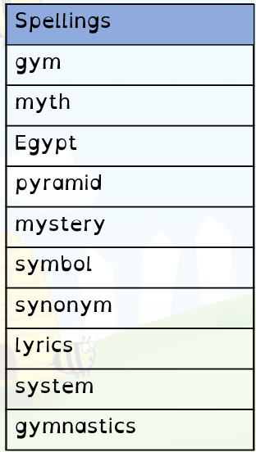 | 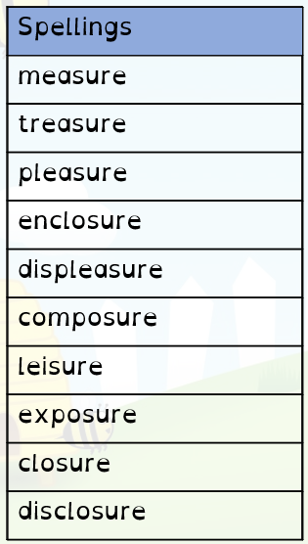
Week 6 – Tested 10th October | Week 7 – Tested 17th October | Week 8 – Tested 24th October
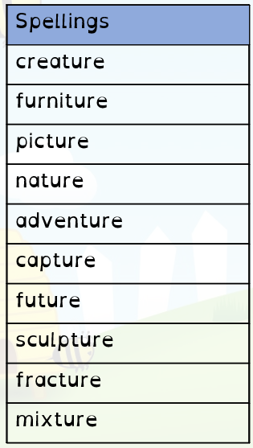 | 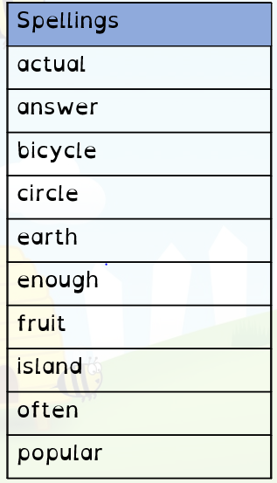 | 

