Viking Vocabulary
Anglo-Saxons | people living in Britain when Vikings invaded
Dane | what the Anglo-Saxons called a Viking invader
Danegeld | payment to make the Viking raiders go away
Danelaw | area of England under Viking rule
horn cup | drinking cup made from animal horn
invade | enter a country or area using force
jarl | powerful Norse chief
longhouse | Viking home made from wood, stone or turf
longship | long, wooden ship used by the Vikings
monastery | place where monks live and worship
Norse | from countries where Vikings came from
Pagan | someone who worships many gods or goddesses
pillage | steal in a violent way
Fjord
saga | long story or poem told by the Vikings
vessel | ship
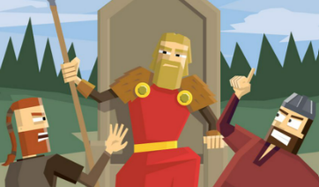
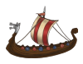
Vikings Knowledge Organiser


