PSCHE – Personal, Social, Citizenship, Health and Economic Education
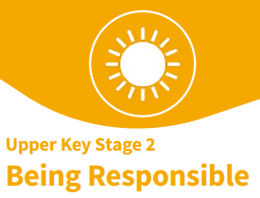
Core Theme: Living in the Wider World

Year: 5 | Term: Spring 2
Key Knowledge
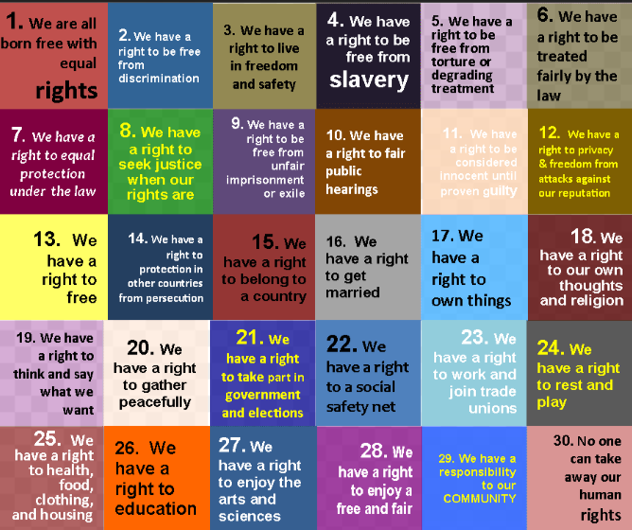
Key Learning
L1 - Research, discuss and debate topical issues
L2 – Explain using examples why rules are needed in different situations.
L3, L4 - Understand that there are human rights to protect everyone, why we have them and that everyone has responsibilities to protect those rights.
L5 - Understand there are some cultural practices against British law.
L7 - Explore rights and responsibilities at home, school, community and the environment. Recognise the importance.
L7 – Continue to develop skills to carry out responsibilities
L8 – Continue to explore how to resolve differences and explore others’ points of view.
L9 - Know what being part of a community means and how they belong.

What I have learnt already
L2 - Identify why rules are needed in different situations.
L7 - Explore rights and responsibilities, rights and duties at home, school, community and the environment.
L7 - Develop skills to carry out responsibilities.
L8 - Explore how to resolve differences and respect others’ points of view.
L9 - Explore what being part of a community means and how they belong.
Our PSCHE Ground Rules…
- We listen to each other.
- We show respect.
- We support each other.
- We ask questions if we want to.
- We know we can talk to any adult in school if we want to talk or need help.

Key Vocabulary
responsible | responsibilities | human rights
community | environment | differences
belonging | resolve | points of view
needs | wants | decisions
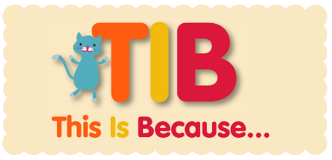
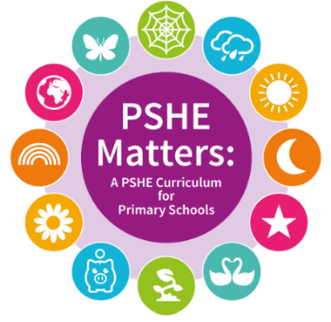
We need the skills and knowledge to know how to be respectful and responsible. We need to understand what our rights are.

