Great  Britain | England, Wales and Scotland
UK | England, Wales, Scotland & Northern Ireland
British  Isles | 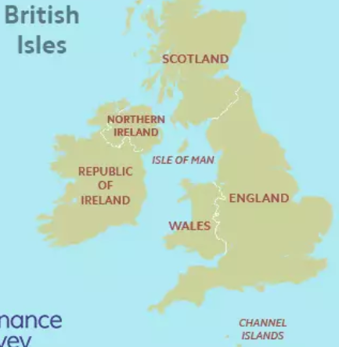
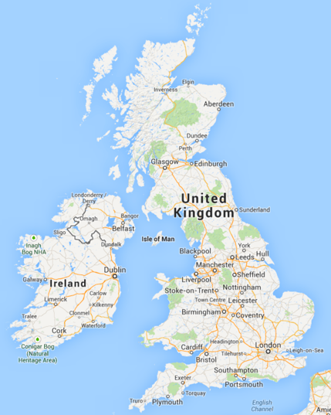
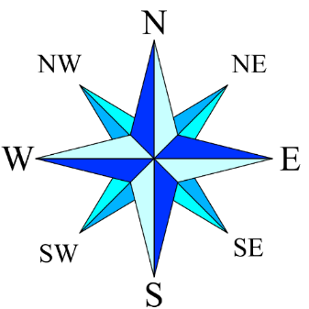
Geography Knowledge Organiser

Compass
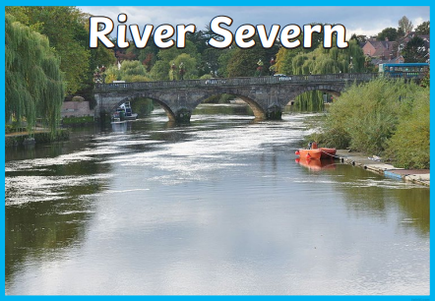
River | A large natural stream of water flowing in a channel to the sea, a lake, or another river.
Sea | An expanse of salt water that covers most of the earth's surface and surrounds its land masses. Usually where land and ocean meet.
Ocean | A very large expanse of sea.
Estuary | An estuary is a partially enclosed, coastal water body where freshwater from rivers and streams mixes with salt water from the ocean

Physical Geography
Physical geographers observe, measure, and describe Earth’s surface. They study how landforms develop and how they change. They look at how different landforms affect climate. They also study how people change the land through such activities as building cities, digging mines, and clearing forests.
Human Geography
Human geography focuses on where people live, what they do, and how they use the land. Human geographers might study why cities and towns develop in certain places. Others study the cultures of different peoples, including their customs, languages, and religions.
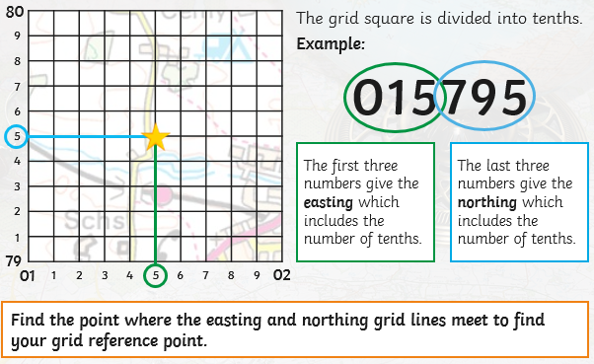
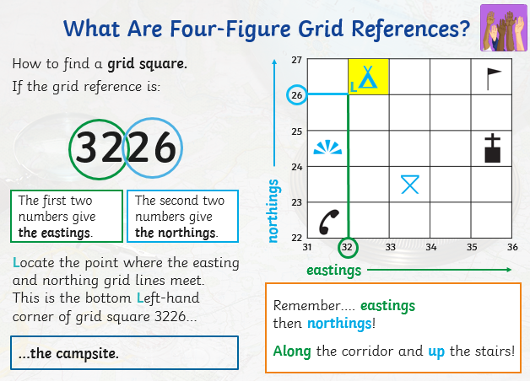

What is a National Park?
It is an area of countryside, or occasionally sea or fresh water, protected by the state for the enjoyment of the general public or the preservation of wildlife. You will find many of the UK’s magnificent hills and mountains in National parks.

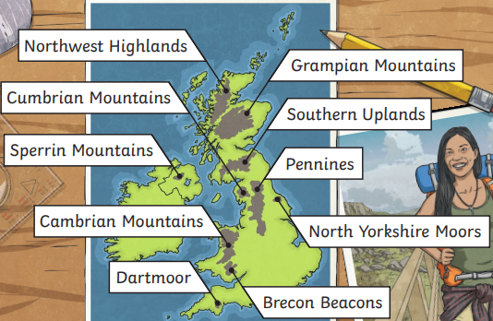
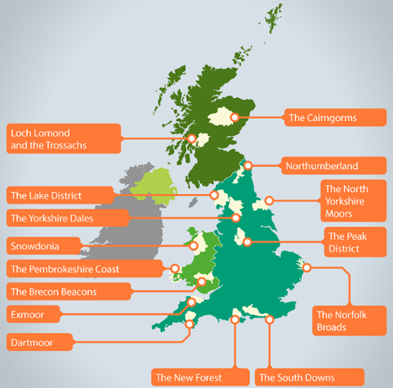
Aerial map: a map from above. Sometimes referred to as a bird’s eye view.
Topographical: a map that shows features of the land such as height. It can show contours and terrain.
Contour: Contour lines on a map are brown lines connecting points of equal height above sea level, revealing the shape and steepness of terrain like hills, valleys, and ridges. Close lines mean steep slopes.

