Year 6 Spellings. Spring term 2. 2025.
Tested on 28th February | Tested on 7th March | Tested on 14th March | Tested on 21st March | Tested on 28th March | Tested on 4th April
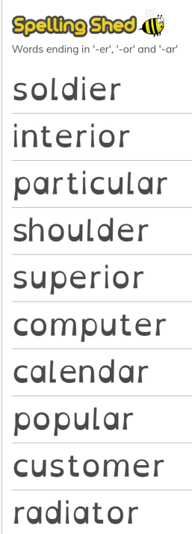 | 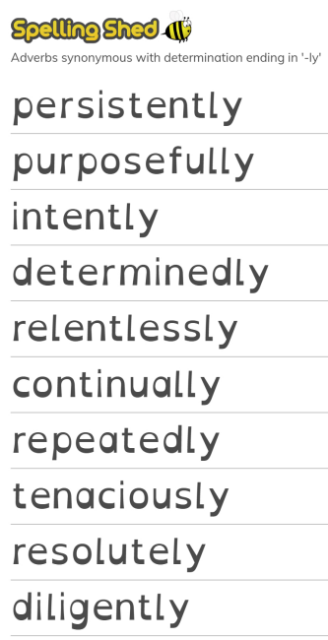 | 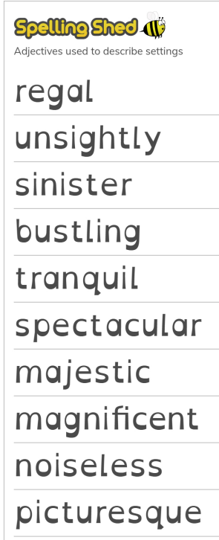 | 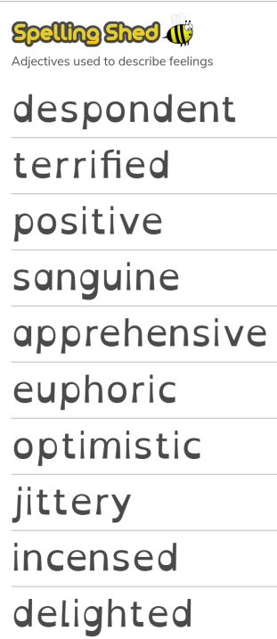 | 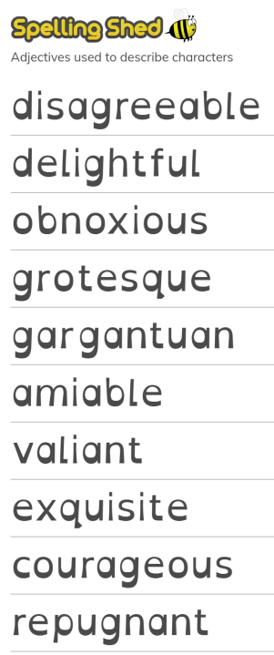 | 

